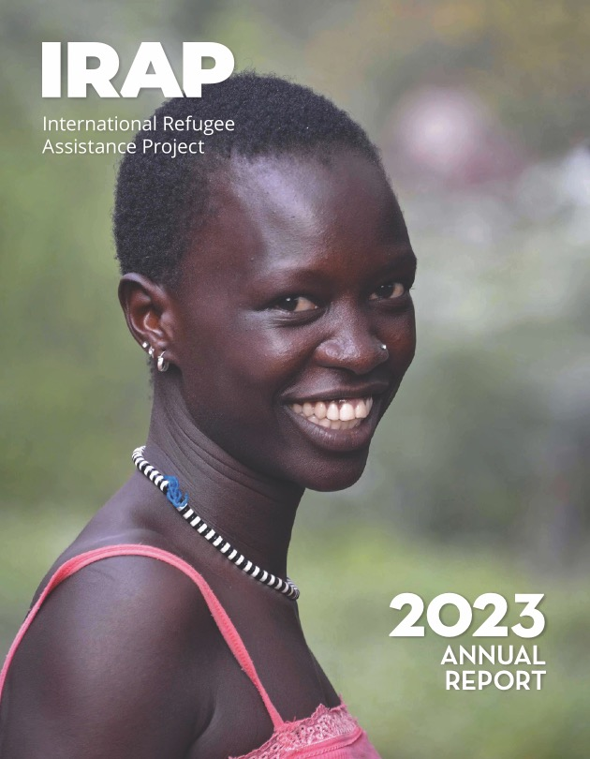

Copyright © 2023

International Refugee Assistance Project, Inc.
All rights reserved

Printed in the United States of America
www.RefugeeRights.org
Cover photo credit: Rod Waddington
Note: The content of this Report is current as of September 2023.
For the security and privacy of clients, some of the names in this Report have been altered or omitted.

Table of Contents
Letter from the Chief Executive Officer 4-6
Our Impact by the Numbers 7-10
Reuniting Families Worldwide 11-14
Increasing Global Access to Family Reunification
Helping Refugee Families Reunite Safely in Europe
Protecting Family Reunification in the United States
Developing a Global Refugee Support Ecosystem 15-18
Partnering with Refugee-Led and Community-Based Organizations
Broadly Disseminating Legal Resources for Refugees and Advocates
Supporting People on the Move Across the Americas 19-23
Upholding Access to the U.S. Asylum System
Expanding Partnerships for Information Exchange with Local Organizations
Providing Adaptive and Timely Legal Support
Ensuring Equity of Access to Safety and Resources 24-28
Fighting for Equal Protection for Refugees in Jordan
Providing Legal Representation to Minority Refugee Populations in Lebanon
Advocating for Refugee-Friendly Policies in the United States
Strengthening and Expanding Existing Pathways to Safety 29-30
Unlocking NGO Referrals to the U.S. Refugee Admissions Program
Holding the U.S. Government Accountable for its Promises to Afghan and Iraqi Allies
Innovating New Pathways to Safety 31-32
Historic Launch of U.S. Private Sponsorship of Refugees
Developing Legal Protections for Climate-Displaced People
Student Chapters 33-34
Pro Bono Partners 35-36
Our Supporters 37-38
Board of Directors and Advisory Board 39-40
IRAP, Inc. Fiscal Year 2023 Financials 41-42
Letter from the Chief Executive Officer

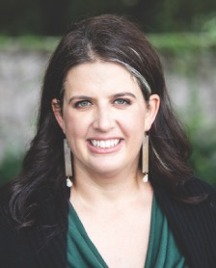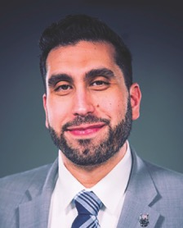
Dear IRAP Community,
As the number of people forced to flee their homes because of the climate crisis, persecution, and conflict continues to break global records, the need for equitable, accessible pathways to safety remains urgent. With humility and ambition, IRAP is collaborating with clients, partnering with refugee-led and community-based organizations, providing direct legal services, sharing legal information, and advocating for systemic change so that everyone has a safe place to live and a safe way to get there.
To realize our vision for expanding our global reach and impact, IRAP continues to grow responsibly and sustainably. We made several key hires in the last year to enable us to bring our work to scale, including IRAP’s first-ever President, Sharif Aly, who is helping to facilitate our increasingly global programming and providing valuable additional expertise and capacity as part of our Executive Leadership Team. Sharif joined IRAP in July 2023, after serving as the Chief Executive Officer (CEO) of Islamic Relief USA. At the same time, my title and role changed to CEO of IRAP. I am excited to share leadership with Sharif and am grateful for his experience, insight, and passion for the protection of refugee rights, which have already made a significant contribution to advancing our mission.
IRAP is also growing our roster of refugee-led and community-based partner organizations in strategic geographic regions to strengthen the global refugee-serving ecosystem, while enhancing our partnership-oriented staff capacity. This year, following a robust assessment of unmet legal needs and protection gaps faced by displaced people in 22 countries across three regions, we added four organizations – in Indonesia, Kenya, and Mexico – to our existing portfolio of partners in which we invest financially and with which we collaborate programmatically. We also released a report elevating the insights of local organizations working in the regions assessed, which underscored the widely-expressed need for more legal information and legal support for people experiencing displacement and the organizations serving them worldwide.
To meet this need, we are developing an expanded digital infrastructure for sharing legal information and resources. Recent hires in two newly-created positions – a Chief Technology Officer and a Director of Digital Resources, Products, and Engagement – have initiated the research and design phase of building our ambitious new legal resource platform, which will push the envelope on accessibility for all users. This reflects IRAP’s broader commitment to diversity, equity, inclusion, and accessibility (DEIA), and dovetails with our plan to launch an innovative disability inclusion and accessibility program at IRAP in the coming year. Through this work, we aspire to highlight the intersection of disability rights and migration, decrease barriers for people with disabilities seeking safety, and level up inclusion and accessibility within IRAP.
This year, IRAP celebrated the achievement of many of our policy and programmatic objectives. IRAP Jordan made important progress in fighting for equity of access to protection and services for refugees in Jordan, particularly people who are HIV-positive or who identify as LGBTQIA+. IRAP Lebanon launched a new pilot project with the UN Refugee Agency to provide critical legal representation to minority displaced populations in Lebanon as they navigate the resettlement process. And IRAP Europe took strides to begin leveraging international courts to expand access to European family reunification systems. Furthermore, in the United States, we are gratified by the launch of notable policies and programs for which we advocated, including a comprehensive private sponsorship program for refugees and the creation of a new pathway that could expeditiously reunite tens of thousands of families who might otherwise remain separated for years or decades. Lastly, we are gaining momentum in our work to develop legal pathways for people displaced by climate-related events worldwide, with initial focus on the Americas.
Yet, even as we take pride in victories, we reflect on the challenges still faced by displaced people around the world, and remain committed to holding governments accountable and standing up against injustice. The past year, which marked the somber second anniversary of the Taliban’s return to power in Afghanistan and the twentieth anniversary of the U.S. invasion of Iraq, also brought seismic changes to the systems serving displaced people across the Western Hemisphere. These changes were led by shifts in U.S. policies, many of which are profoundly unjust and harmful to forced migrants. As we continue to push the Biden administration to fulfill its obligation to provide refuge to U.S. affiliated Afghans and Iraqis, we are also advocating vigorously to defend the integrity of U.S. asylum and resettlement systems.
In everything we do, the IRAP team holds ourselves to the principles of anti-racism and global justice, internally as an organization and externally in our partnerships and programmatic work. Looking ahead, we will continue to innovate side-by-side with displaced people and other partners in an effort to ensure that everyone can live in safety and dignity with their loved ones.
We are profoundly grateful to you, our community of supporters, for journeying with us all.
Sincerely,
Becca Heller
Chief Executive Officer
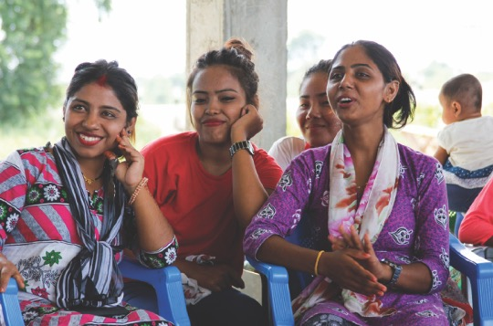 Photo Credit: Steph Moor / DFID

Our Impact by the Numbers
This year, IRAP provided legal counseling and representation to 3,497 clients located in 67 countries. We also provided legal information to more than 157,700 people.
The clients we served include*:
33% People seeking to reunite with their families
Half of all family reunification cases included a minor
33% U.S. affiliated Afghans and Iraqis and their families
22% Survivors of sexual and gender-based violence and at-risk women
15% People with medical vulnerabilities
14% Survivors of torture and other violence
6% Asylum seekers at the U.S. Mexico border
6% L.G.B.T.Q.I.A. people experiencing persecution
6% People facing religious persecution
* Client risk factors may intersect.
92% * * of cases IRAP represented had a positive outcome, which includes resettlement, family reunification, and other legal benefits.
* * Percentage of positive outcomes among cases with known outcomes.

133,882 people benefitted, or stand to benefit, from systemic change efforts including policy advocacy and impact litigation.

Our Impact by the Numbers
Since IRAP’s founding in 2008:
We have provided legal counseling and representation to over 41,200 clients in more than 100 countries.
Our legal information website, offering self-help legal resources in eight languages, has been visited by more than 359,400 people since it was launched in 2019.
35,744 people have used IRAP’s Chatbot to access tailored information about their eligibility for pathways to safety – and connect with staff when we can offer legal assistance — since it was created in 2019.
Our litigation in U.S. courts has benefitted and stands to benefit more than 495,000 people.
Our policy advocacy has protected and expanded pathways to safety in the United States for more than 500,000 people.
IRAP has built a network of more than 6,400 pro bono attorneys and student volunteers advocating for refugees’ rights.

“No organization has been able to help me, except for IRAP… [IRAP] has been helping me step by step and has treated me like a family member.”
— Russel, IRAP Client

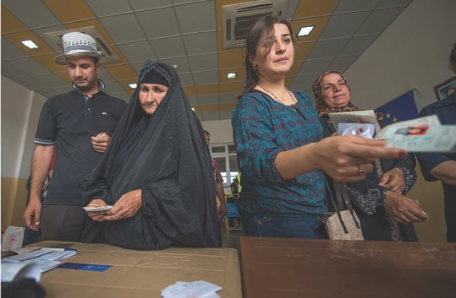
Photo Credit: EU Civil Protection and Humanitarian Aid

Reuniting Families Worldwide
IRAP is a world leader in reuniting separated refugee family members through global legal aid and advocacy. This year, we helped 961 people navigate complex family reunification pathways to safely rejoin loved ones.
Increasing Global Access to Family Reunification
Building on our direct legal aid, our litigation and policy teams leverage learnings from individual cases to remove unjust systemic barriers and defend family reunification programs against legal challenges. IRAP also works to help more people access family reunification by sharing our expertise with partners across the global refugee-serving field.
In late 2022, we concluded our three-year, regional family reunification pilot program with the UN Refugee Agency and RefugePoint, through which IRAP represented hundreds of separated refugee families. This program helped facilitate the broader use of historically underutilized family reunification pathways. We are excited to build on the pilot’s success through a recently executed one-of-a-kind global agreement that will allow all UN Refugee Agency offices worldwide to refer family reunification cases to IRAP. Expanded access to family reunification stands to benefit millions of displaced refugee family members seeking to reunite in safety.
Helping Refugee Families Reunite Safely in Europe
Our IRAP Europe team reunites separated refugee family members and provides legal support to partners in European countries. This year, we assisted 421 people with claims for family reunification in Europe and trained hundreds of local refugee advocates on family reunification eligibility requirements and application processes, as well as how to refer cases to IRAP for assistance. In Sweden alone, we trained over 230 social workers across the country, creating a nationwide web of knowledgeable advocates.
Expanding on our efforts to use client insights to improve family reunification systems, we added a European litigator to our team to leverage international courts in Europe. IRAP Europe also leads our partnership with Equal Rights Beyond Borders in Greece, which, with IRAP’s support, has assisted in over 1,000 family reunification cases and challenged more than 100 unjust denials in court, with a success rate of over 75%.

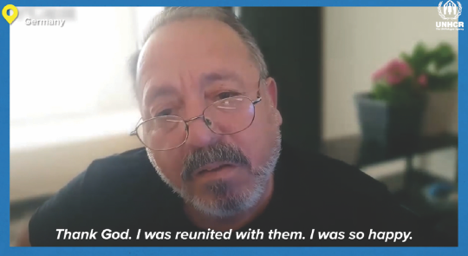
CLIENT Story:
Ahmed

Ahmed is a father of three from Homs, Syria, who was working in Libya when the Syrian civil war broke out in 2011. His children, who were still in Syria at the time, fled through multiple countries before reaching safety in Germany, where they have since started families of their own.
Because there is no German embassy in Libya, Ahmed could not apply for reunification with his family. For more than a decade, Ahmed felt the weight and solitude of being separated from his loved ones. He watched from afar as his children became adults and his grandchildren were born. Ahmed spent years trying to navigate the complexities and requirements of the family reunification process set forth by the UN Refugee Agency, Libya, and Germany. Ahmed’s case was ultimately referred to IRAP Europe through our partnership with the UN Refugee Agency, and this year, we were able to help him unlock his pathway to family reunification and safety in Germany.
Ahmed worked with the UN Refugee Agency to share his family’s story in a video for World Refugee Day. Now that they are reunited, he is thrilled to be closely involved in his children’s and grandchildren’s lives. “Now, when I don’t see them for even one day, I miss them…The happiness is indescribable,” Ahmed shared.

Reuniting Families Worldwide
Protecting Family Reunification in the United States
This year, IRAP provided legal aid to 540 separated refugee family members seeking to reunite in the United States and furthered access to U.S. family reunification pathways. In a significant advocacy win, the U.S. government adopted our recommendation for a new program that will enable tens of thousands of individuals with approved family reunification applications to enter the United States while their cases are in process.
IRAP remains a steadfast advocate for the Central American Minors (CAM) Refugee and Parole Program, which was designed to enable children in danger in Honduras, Guatemala, and El Salvador to safely join their families in the United States. This year, as part of our ongoing litigation defending CAM against challenges by certain U.S. states, IRAP intervened in the litigation on behalf of four clients seeking to bring their children to safety through CAM. As a result, they are able to speak powerfully about the importance of this family reunification pathway and help defend it in court. We also released a report highlighting the barriers separated families face in accessing CAM, and in April 2023, we celebrated the U.S. government’s adoption of several program enhancements recommended in our report. In partnership with Latham & Watkins LLP, we are seeking renewal of expiring status for CAM parolees in the United States, ensuring that families continue to benefit from the program.
Additionally, with law students and pro bono attorneys from Weil, Gotshal & Manges LLP; Covington & Burling LLP; Patterson Belknap Webb & Tyler LLP; and Greenberg Traurig, LLP, we have stepped up our use of the courts to compel the U.S. government to complete processing of stalled refugee family reunification cases. These lawsuits move individual cases forward and pressure the government to undertake systemic reform. They also highlight ongoing delays that families face in being reunited, as a result of residual effects of unjust policies initiated under the rescinded 2017 Muslim ban, which prevented Black and Muslim people from seven Muslim-majority countries from entering the United States.
To increase public awareness of widespread, protracted refugee family separation in the United States, IRAP worked with partners to launch the How Many More Years? advocacy campaign. As part of the campaign, IRAP clients and refugee community leaders shared their stories, motivating hundreds of people in the United States to call on President Biden to invest in family reunification pathways.

Left: IRAP client Raj with his wife and eldest son shortly before they were separated.
Right: Raj and his family reunited this year after nearly a decade apart.

Developing a Global Refugee Support Ecosystem
IRAP is strengthening our global partnership network to build a more robust and connected refugee support ecosystem, close widely-expressed gaps in legal information, and increase public support for displaced populations.
Partnering with Refugee-Led and Community-Based Organizations
In an IRAP assessment of protection and service gaps faced by displaced people across Africa, Latin America and the Caribbean, and South and Southeast Asia, which included interviews with 107 local and refugee-led organizations in 22 countries, the most commonly identified needs were increased legal information and direct legal assistance.
We published a report highlighting community-based organizations’ critical efforts to address these gaps, and are working with community-based initiatives to expand access to IRAP resources. Supplementing our ongoing partnerships with Derechos Humanos Integrales en Acción and Equal Rights Beyond Borders, IRAP formalized new partnerships to subgrant to and collaborate with four refugee-led organizations: Apoyo a Migrantes Venezolanos in Mexico; Refugee and Asylum Seekers Information Centre in Indonesia; Refugee-Led Organization Network of Kenya; and Youth Voices Community, also in Kenya. This year, IRAP staff traveled to Kenya, Indonesia, Mexico, and Central America to learn more from partners about the challenges that their communities face.
Broadly Disseminating Legal Resources for Refugees and Advocates
IRAP is expanding our digital resources for forced migrants to help meet the acute need for information. To support this digital information infrastructure, this year we hired for two new positions: a Chief Technology Officer and a Director of Digital Resources, Products, and Engagement. They are leading our efforts to increase resource accessibility, including for users with disabilities, by offering reliable information in relevant languages like Haitian Kreyòl and using flexible information-sharing methods, such as QR codes and shortlinks. Displaced people around the world can request help from IRAP using our Chatbot, which connects users with tailored legal resources and directs eligible people to IRAP’s Global Screenings and Casework team for screening.
We also share our expertise with other legal practitioners. This year, IRAP staff trained over 1,700 advocates to help displaced people of all nationalities navigate resettlement pathways. Our Ask an Expert online portal allows those supporting Afghans to seek guidance directly from IRAP; to date, we have answered 186 questions, which have been viewed online more than 3,000 times.
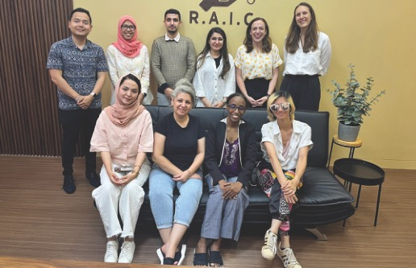
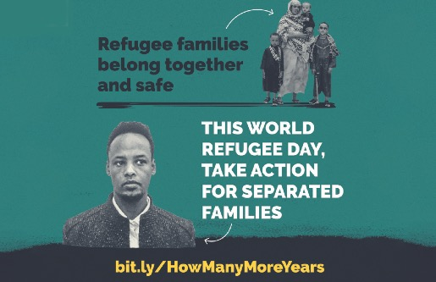
Developing a Global Refugee Support Ecosystem
Changing Prevailing Narratives About Displaced Populations
IRAP’s narrative change strategy amplifies refugee viewpoints and influences public opinion on necessary systemic reforms.
Our clients and staff were quoted in dozens of media outlets, such as Al Jazeera, The Atlantic, The New York Times, and The Washington Post. IRAP also sought Afghan community leaders’ perspectives on findings obtained through a Freedom of Information Act request that the U.S. government failed to process thousands of humanitarian parole applications filed by Afghans since the U.S. military withdrawal in August 2021 – and in a blog post, we featured their insights, which were later included in reporting by New Lines Magazine.
Client Storytellers:
Family Reunification Advocacy Campaign
Seven, nine, and ten years. That’s how long IRAP clients Raj, M.A., and Rabi have been separated from their loved ones. In partnership with IRAP, they mounted legal challenges to reunite their families and spurred hundreds of people into action through our How Many More Years? advocacy campaign.
Rabi’s Story:
Rabi grew up in a refugee camp in Ethiopia. He met his wife and started a family of his own in the camp while waiting to be resettled. When he finally reached safety in Minnesota, he thought his wife and sons would follow shortly after.
After seven years without updates, Rabi worked with IRAP to file a lawsuit to speed up government processing of his family’s case. He has also advocated in local and community media like Minnesota’s KARE 11 news and the Sahan Journal. Because of increased pressure, the U.S. government finally completed Rabi’s first stage of case processing, but Rabi and his family still have a long way to go before they are reunited.

Raj’s Story:
For nearly a decade, Raj, a resettled Tamil refugee, celebrated his sons’ birthdays and first days of school through pictures and video calls, and feared for his family’s safety in Sri Lanka. Last Father’s Day, Raj shared, “The stress of our separation and the constant threats to their safety have taken a toll...I love…my life in this country...Yet I know my life here will remain incomplete without my family.”
Through Raj’s litigation and public advocacy efforts with IRAP, after years without progress on their case, Raj and his family were joyfully reunited in the United States this August.
M.A.’s Story:
M.A. and her family, members of a persecuted Muslim minority group in Burma, had hoped to flee Burma together, but facing financial challenges, her father stayed behind so his wife and four daughters could seek safety.
M.A., now a college student in Indiana, is grateful for her father’s sacrifice, but she fears for his safety and dreams of the day they will be reunited. In a Father’s Day op-ed, she reflected, “My dad constantly tells me how proud he is of me, but we were both devastated that he wasn’t able to attend my high school graduation. The longer our reunification is delayed, the more of these moments he misses.”

Supporting People on the Move Across the Americas
This year, fast-changing U.S. government policies had a profound impact on migrant communities throughout the Western Hemisphere, particularly asylum seekers at, or on their way to, the U.S. Mexico border.
In response, IRAP built upon our well-established partnership with Derechos Humanos Integrales en Acción (DHIA) in the Ciudad Juárez/El Paso border area and grew our network of partners across Mexico and Central America to continue delivering legal services and information to people seeking safety in the United States and advocating for dignified, equitable legal pathways.
Upholding Access to the U.S. Asylum System
IRAP is pushing vigorously through policy advocacy and strategic communications to minimize the harmful impact of U.S. government policies that erode access to asylum at the U.S. Mexico border.
In spring 2023, the Biden administration announced an overhaul of U.S. asylum and resettlement systems for the Western Hemisphere, including unwelcome policies that unjustly restrict the ability of people at the U.S. Mexico border to seek asylum, as well as more promising programs that have the potential to expand humanitarian pathways to safety for certain people. One such policy is a new family reunification parole program, which IRAP helped design and advance, that stands to benefit tens of thousands of families.
However, these new programs must not come as a trade-off for limiting the legal rights of people seeking asylum nor hinder refugee processing from other parts of the world. IRAP’s efforts to raise awareness of the unlawfulness and harmful impact of many of the Biden administration’s new policies were picked up by leading U.S. media outlets, including Associated Press, Los Angeles Times, The New York Times, and Spanish language newspapers across the country, as well as Last Week Tonight with John Oliver.

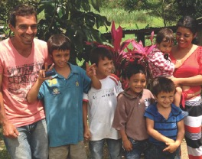
Photo Credit: USAID U.S. Agency for International Development
Expanding Partnerships for Information Exchange with Local Organizations
In March 2023, IRAP grew and strengthened our network by conducting in-person interviews with approximately 75 organizations serving forced migrants in southern Mexico, Guatemala, El Salvador, and Honduras. These conversations enabled us to share many new substantive insights with the White House in our June 2023 recommendations for the expansion of the U.S. Refugee Admissions Program (USRAP) and implementation of new programs, in light of Western Hemisphere policy developments.
Our field interviews also confirmed an acute need for accurate legal information and services related to U.S. refugee and immigration processes, particularly at the U.S. Mexico border. To help fill this gap, in May 2023, just two weeks after the Biden administration lifted Title 42 (which had spuriously closed the border to asylum seekers during the COVID emergency), IRAP published comprehensive legal information simultaneously in English, Spanish, and Haitian Kreyòl to empower individuals to make informed decisions about how to seek entry to, and or seek asylum, in the United States. In addition, we began collaborating with our new partner, the Mexico City-based organization Apoyo a Migrantes Venezolanos, to jointly create and distribute digital legal resources. We are now working with our regional network to expand and formalize accessible information-sharing processes.
Supporting People on the Move Across the Americas
Providing Adaptive and Timely Legal Support
In the volatile policy landscape, IRAP has continually adapted to ensure that migrants can access critical legal support. In late 2022 and early 2023, IRAP helped 149 clients secure exemptions to Title 42 before it was repealed.
At the beginning of 2023, the administration infringed upon people’s legal right to seek protection at U.S. borders by requiring those seeking entry to the United States to make appointments through the smartphone-based CBP One application. As IRAP clients helped us identify numerous barriers to using the app – including linguistic ones (error messages appeared in English even after the app was translated, for example), issues with facial recognition technology failing for Black and Indigenous people with dark skin, and other technological glitches – we adjusted quickly to develop workarounds.
In May 2023, when Title 42 ended, the United States reinstated expedited removal proceedings with minimal procedural protections and began implementing an asylum ban, which requires most non-Mexicans who enter the United States without an appointment to pass an elevated credible fear interview (CFI) to even have a chance to apply for asylum. IRAP immediately took steps to begin providing CFI preparation to those hoping to seek asylum in the United States, helping to improve their chances of being able to remain in the United States and potentially apply for asylum.
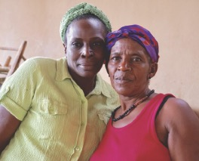
Photo Credit: Heather Suggitt

Photo Credit: Claudia Altamimi
Client Story:
Georges* and Vincent*
Brothers Georges* and Vincent* fled Haiti for the Dominican Republic after a local gang targeted their family. When members of the gang even tracked them down in the neighboring country, Georges and Vincent fled to Chile. There, they were attacked at gunpoint by men believed to belong to the same gang, forcing them to flee yet again – this time to Mexico. While the brothers plan to seek safety in the United States, they have been forced to wait indefinitely in Mexico, where Vincent is unable to access needed medical treatment.
Despite facing threats and targeted violence in more than one transit country, as well as significant medical needs, under the Biden administration’s asylum ban, Georges and Vincent do not even have the opportunity to present an asylum claim, let alone have their claims meaningfully considered.
As part of IRAP’s advocacy challenging the asylum ban when it was first proposed, IRAP shared stories from clients like Georges and Vincent to illustrate the dangerous, real-world ramifications of undermining access to asylum.
*Name and photo changed to protect client identity.

Ensuring Equity of Access to Safety and Resources
IRAP is committed to equalizing access to safety by assisting displaced people who are marginalized, disenfranchised, historically excluded, or otherwise at elevated risk of severe harm, and prioritizes working with populations who are unable to access legal assistance and resources due to systemic barriers.
Fighting for Equal Protection for Refugees in Jordan
In Jordan, IRAP plays a leading role advocating for a legal framework inclusive of all refugee groups as co-chair of the One Refugee Approach Working Group. This year, our efforts resulted in the formal inclusion of minority (non-Syrian) refugee groups in work plans for humanitarian assistance providers and multilateral and bilateral funders, a significant step towards ensuring that all displaced populations in Jordan have equitable access to humanitarian assistance and other resources, as well as protection from threats including trafficking, detention, and deportation.
We are also advocating for expanded complementary pathways to safety, which provide opportunities to reach refuge outside of traditional resettlement by the UN Refugee Agency, for refugees in Jordan who have HIV or identify as L.G.B.T.Q.I.A. Since early 2023, L.G.B.T.Q.I.A. and HIV-positive community members have faced heightened persecution. In response to the increased safety concerns, we have advocated to expand NGO referrals to humanitarian visa programs, providing additional pathways to safety for all refugees in Jordan.
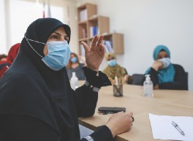
Photo Credit: ILO
Providing Legal Representation to Minority Refugee Populations in Lebanon
IRAP Lebanon is working to ensure that all refugee populations in Lebanon have equal access to protection. In the summer of 2023, the Lebanon team initiated a pilot project with the UN Refugee Agency to provide legal representation for non-Syrian refugee populations in Lebanon, such as people from Egypt, Ethiopia, Iran, Sudan, and Yemen, as they navigate the refugee status determination step of the UN resettlement process. Being formally recognized as refugees by the UN Refugee Agency allows people to gain access to vital humanitarian services, become eligible for consideration for resettlement, and secure protections against deportation.
Advocating for Refugee-Friendly Policies in the United States
IRAP partners with constituents and leaders in communities across the United States to convert broad support for refugees into welcoming state and local policies that can withstand shifting political winds at the national level. As a co-founder of the Refugee Advocacy Lab (the Lab), IRAP advocates and provides technical legal support to advance this objective.
This year, we continued to prioritize direct engagement with refugee leaders as we contribute to Lab efforts. For example, after soliciting input from refugee leaders on policy priorities, IRAP led the development of a guide on in-state tuition access for displaced people and undertook advocacy to improve relevant laws. These endeavors were catalyzed by the experiences of Afghan women who came to the United States as parolees to escape Taliban rule, including its restrictions on women’s education, only to discover that they could not afford to pursue higher education because they were ineligible for in-state tuition regardless of how many years they resided in the state. By publishing op-eds featuring the stories of Afghan women and resources on in-state tuition, IRAP and the Lab supported legislators, refugee leaders, and advocates in places like Georgia, Utah, and Kansas to introduce or pass bipartisan legislation on in-state tuition. Utah now has the most expansive in-state tuition policies in the country, providing access to refugees, Special Immigrant Visa (SIV) holders, and other newly eligible groups.
We have also engaged our law student chapters in this work. For example, IRAP supported our University of Michigan student chapter in advocating for in-state tuition for humanitarian parolees, Temporary Protected Status holders, and asylum seekers at their school. As a result, the school removed from its website its policy stating that parolees are ineligible for in-state tuition, and is currently reviewing the policy itself.
Similarly, based on direct calls from refugee leaders for better access to mental health support, IRAP, in partnership with the Center for Victims of Torture, took the lead on creating a resource and hosting a webinar on relevant best practices. Since its publication in May, the resource has attracted the highest number of visits on the Lab’s website, and several refugee advocates and partner organizations have already started to develop plans to pursue policy advocacy in this area.

Photo Credit: Governor Jay Inslee
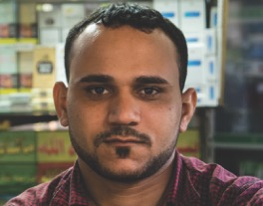
Photo Credit: Mark Fischer
Client Story:
Nabeel*
When he was just 18 years old, Nabeel* fled from Egypt to Jordan. He had been physically and psychologically tortured by his family and forced to undergo conversion therapy because he is gay. Nabeel escaped to Jordan after learning that his family planned to kill him.
Although he was no longer subjected to his family’s abuse once in Jordan, Nabeel continued to face significant dangers related to homophobic discrimination and violence. He was also unable to seek protection because, since January 2019, the Jordanian government has prohibited the UN Refugee Agency from registering non-Syrian refugees. Without any options for resettlement or lasting safety in Jordan, Nabeel was at constant risk of arrest and deportation.
Given the urgency of Nabeel’s protection needs, IRAP Jordan staff submitted a referral to the U.S. embassy in Jordan advocating for him to be granted Priority 1 access to the U.S. Refugee Admissions Program (USRAP). His refugee status was approved, and he was resettled to a U.S. city where he now has access to a vibrant and well-established L.G.B.T.Q.I.A. community.
*Name and photo changed to protect client identity.
Strengthening and Expanding Existing Pathways to Safety
IRAP is committed to maintaining and improving existing global pathways to safety for displaced people.
Unlocking NGO Referrals to the U.S. Refugee Admissions Program
This year, IRAP’s advocacy helped advance the Biden administration’s momentous decision to create a formalized program for NGOs to refer eligible clients directly to the U.S. Refugee Admissions Program (USRAP), expanding access to U.S. resettlement for the many refugees unable to secure referrals from the UN Refugee Agency.
Now, we are designing and implementing the NGO referral program as part of the Equitable Resettlement Access Consortium, with partners HIAS and RefugePoint, including training other organizations worldwide to make referrals. Our global screenings and casework, Lebanon, and Jordan teams are identifying potential clients – such as refugees who are prohibited from registering with the UN Refugee Agency due to their nationality, their Palestinian origins, or restrictive laws in their country of first asylum – for whom this new pathway may be appropriate.
Holding the U.S. Government Accountable for its Promises to Afghan and Iraqi Allies
On the second anniversary of the U.S. withdrawal from Afghanistan and the twentieth anniversary of the U.S. invasion of Iraq, IRAP continued pushing the Biden administration to protect hundreds of thousands of U.S. affiliated Afghans and Iraqis.
With the Evacuate Our Allies advocacy coalition, we continue to call for the passage of the Afghan Adjustment Act, which would provide a pathway to permanent status for Afghans temporarily admitted to the United States since August 2021. IRAP also obtained a key win in late 2022 in our longstanding case with pro bono co-counsel Freshfields Bruckhaus Deringer US LLP challenging egregious delays in the Special Immigrant Visa (SIV) program. The court rejected the Biden administration’s attempt to get out of a court-ordered plan for expeditiously processing tens of thousands of SIV applications.
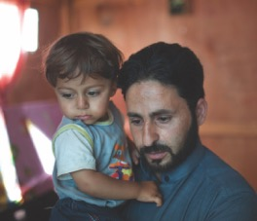
Photo Credit: Dominic Chavez / World Bank
Client Story:
Hashim*
After fleeing Syria, Hashim* began building his life in Lebanon. He worked hard to provide for his family, but experienced exploitation by employers because he could not access a work permit.
In light of the family’s protection concerns, they registered with the UN Refugee Agency and waited to be resettled, but the threats continued, reaching a terrifying inflection point in March 2021 when Hashim was nearly forcibly returned to Syria. He was taken to the Lebanon-Syria border and forced to run up a mountainside while being shot at, and finally hid behind a boulder until sunrise.
After this violent attempt to force Hashim back to Syria, he and his family went into hiding, and his attackers again began to search for him. Hashim and staff from IRAP Lebanon collaborated to move his case forward. Finally, this past summer, Hashim and his family resettled to the United States.
*Name and photo changed to protect client identity.
Innovating New Pathways to Safety
IRAP is working to open new pathways to safety for refugees and forced migrants around the world.
Historic Launch of U.S. Private Sponsorship OF Refugees
After years of IRAP advocacy, the launch of U.S. private sponsorship of refugees through the Welcome Corps program represents the boldest innovation in U.S. refugee admissions in decades, opening an entirely new pathway for resettlement.
IRAP has long called for U.S. private sponsorship because of its potential to expand resettlement to refugee communities who cannot access UN refugee pathways, and to engage a broader cross-section of Americans in welcoming refugees. Now, IRAP is helping to implement the private sponsorship program by developing legal resources for sponsors and refugees. The program’s second phase will allow Americans to name specific refugees they wish to sponsor, helping to maximize the program’s potential to expand and accelerate refugee family reunification.
Developing Legal Protections for Climate-Displaced People
More people are displaced by climate events than any other cause, yet legal frameworks for refugees fail to address climate displacement.
Following a conference of legal and policy advocates seeking solutions to climate displacement in the Americas hosted by IRAP, the Natural Resources Defense Council, and Emerson Collective, we convened a Climate Displacement Legal Working Group that is now mapping potential pathways to safety in the Americas. IRAP is also piloting a questionnaire to collect data on how climate is impacting individual displacement. In March 2023, we co-published the report, Climate of Coercion, which uses preliminary questionnaire data to assess how climate change impacts forced migrants at the U.S. Mexico border.
IRAP stands committed to creating a world where all people seeking refuge – no matter where they are from or why they were forced to flee their homes – are empowered to claim their right to freedom of movement and to live in safety and dignity.
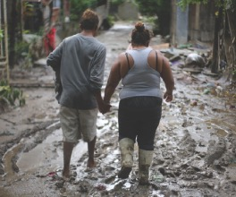
Photo Credit: European Union / D. Membreño
CliMATE OF COERCION REPORT IMPACT Story:
Nayeli*
Nayeli* was forced to flee her home in Honduras after Hurricanes Iota and Eta devastated her family’s home and business, and threats from gang members intensified.
Then, a gang member tried to force Nayeli’s 8-year-old daughter to be his “girlfriend.” “They said if I didn’t give them my daughter they would kill her in front of me,” Nayeli recalled. Nayeli and her family fled Honduras shortly thereafter; at the time of this account, they were staying in a shelter in Tijuana.
Nayeli shared her story to illustrate how climate-related disasters intersect with other drivers of displacement like gang violence and sexual- and gender-based violence.
*Name and photo changed to protect client identity.

Student Chapters
IRAP partners with law school student chapters to develop the next generation of advocates for displaced people.
This year, student chapter members partnered with IRAP to help Afghan Special Immigrant Visa (SIV) applicants obtain Chief of Mission approval, a key step in the SIV process; advocated for IRAP’s policy priorities on Capitol Hill; and traveled to IRAP’s Jordan office for our first in-person student trip since 2020, where they learned to conduct screening and intake interviews for potential clients.
As part of our effort to expand representation in the legal field, in August 2023 IRAP announced a new fellowship program for U.S. based law students with lived experience of displacement or marginalization, and we are excited to welcome five law students as part of the first cohort of fellows.

“Being part of IRAP has been a formative experience of my legal studies. I’m grateful to have met a group of people through IRAP who are equally passionate about improving the lives of people who have been displaced, while maintaining a commitment to centering their agency.”

— Poonam Sandhu, Chapter Director, McGill University Faculty of Law


“Working with IRAP to expand access to in-state tuition for refugees and other people in Michigan has provided amazing insight into the ins-and-outs of what it means to advocate for marginalized communities.”

— Kavitha Babu, Student Volunteer, University of Michigan Law School
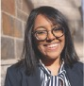

American University Washington College of Law
Boston University School of Law
Columbia Law School
City University of New York School of Law
Emory University School of Law
Fordham University School of Law
George Washington University Law School
Georgetown University Law Center
Harvard Law School
McGill University Faculty of Law
New York University School of Law
Northwestern University Pritzker School of Law
Osgoode Hall School of Law
Rutgers School of Law
Seattle University School of Law
Stanford Law School
Touro Law Center
University of California, Berkeley, Boalt Hall School of Law
University of California, Los Angeles School of Law
University of Chicago Law School
University of Connecticut School of Law
University of Michigan Law School
University of Pennsylvania Law School
University of Southern California, Gould School of Law
University of Virginia School of Law
Yale Law School

Pro Bono Partners

IRAP’s network of pro bono partners provides clients with critical legal assistance on their journeys to safety and bolsters IRAP’s litigation and advocacy.
In 2022, these partners provided more than 25,600 hours of free legal aid, valued at over $19.6 million.

“Although it’s not possible for me to fully comprehend the experiences of refugees and displaced people, it is deeply rewarding to take on the administrative and procedural tasks that burden our pro bono clients as a means to protect the time and energy they need to focus to on themselves and their families during these difficult transition periods.”

— Michelle Le, Associate, Weil, Gotshal & Manges LLP



AIG
Allen & Overy
Alston & Bird LLP
Arnold & Porter Kaye Scholer LLP
Ashurst
Baker, Donelson, Bearman, Caldwell & Berkowitz P.C.
Ballard Spahr LLP
Barasch McGarry Salzman & Penson
Bradley Arant Boult Cummings LLP
Brown Rudnick LLP
Bush Seyferth PLLC
Cleary Gottlieb Steen & Hamilton LLP
Clifford Chance
Covington & Burling LLP
Davis Wright Tremaine LLP
Dentons
DLA Piper LLP
Duane Morris LLP
Dykema Gossett PLLC
Faegre Drinker Biddle & Reath LLP
Fenwick & West LLP
Fragomen, Del Rey, Bernsen & Loewy, LLP
Freshfields Bruckhaus Deringer
General Electric
Gibson, Dunn & Crutcher LLP
Goodwin Procter LLP
Goulston & Storrs P.C.
Greenberg Traurig, LLP
GxG Legal
Hengeler Mueller
Herrick Feinstein LLP
Hogan Lovells
Holwell Shuster & Goldberg LLP
Hughes Hubbard & Reed LLP
Hunton Andrews Kurth LLP
Hutchinson, Black, and Cook LLC
Jenner & Block
K&L Gates LLP
Kilpatrick Townsend & Stockton LLP
King & Spalding LLP
Kirkland & Ellis LLP
Koskie Minsky LLP
Latham & Watkins LLP
Law Offices of Carl G. Roberts
Linklaters LLP
Littler Mendelson P.C.
Lowenstein Sandler LLP
Manatt, Phelps & Phillips, LLP
Microsoft
Moore & Van Allen PLLC
Morgan Lewis & Bockius LLP
Neal, Gerber & Eisenberg LLP
Nixon Peabody LLP
Orrick, Herrington & Sutcliffe LLP
Parker, Hudson, Rainer & Dobbs LLP
Patterson Belknap Webb & Tyler LLP
Paul, Weiss, Rifkind, Wharton & Garrison LLP
Poles, Tublin, Stratakis & Gonzalez, LLP
Polsinelli LLP
Proskauer Rose LLP
Reed Smith LLP
Ropes & Gray LLP
Rosenstock Legal Services
Rosetta Stone
Schiff Hardin LLP
Seyfarth Shaw LLP
Shearman & Sterling LLP
Sheppard, Mullin, Richter & Hampton LLP
Sidley Austin LLP
Simpson Thacher & Bartlett LLP
Skadden, Arps, Slate, Meagher & Flom LLP
Starbucks
Steptoe & Johnson LLP
Sullivan & Cromwell LLP
Synchrony Financial
The 3M Company
Three Crowns
Venable LLP
Weil, Gotshal & Manges LLP
White & Case LLP
Whiteman Osterman & Hanna LLP
Wilson Sonsini Goodrich & Rosati
Winston & Strawn LLP
Youman, Madeo & Fasano, LLP

Our Supporters

We extend profound gratitude to our generous supporters who made gifts* to IRAP this past fiscal year – September 1, 2022 through August 31, 2023 – and to all who stand with us.

AIG
AJG Fund
Akin Gump Strauss Hauer & Feld LLP
Alchemy Foundation
Allen & Overy
Anna and Carl Reisner
Anonymous (6)* *
Anonymous (23)
Argosy Foundation
Arnold & Porter
Ashurst
Barinaga Goodman Fund of West Marin Fund
Carnegie Corporation of New York
Catena Foundation
Charles and Lynn Schusterman Family Philanthropies* *
Choose Love, Inc.
Chris Dunn
Crystal & Chris Sacca
Democracy Fund
Dentons US LLP
Directions for Rural Action Fund
DKT Liberty Project
DLA Piper LLP (US); The DLA Piper Foundation
Double Up Drive
Duane Morris LLP
Dunn Family Charitable Foundation
Fenwick & West LLP
FJC – A Foundation of Philanthropic Funds
Ford Foundation
Freshfields Bruckhaus Deringer
FWD.us Education Fund
G. Barrie Landry, Landry Family Foundation
Galaxy Gives* *
Gibson, Dunn & Crutcher LLP
Gina Maya and Richard Capelouto
Gloria Principe and John O’Farrell
Google Inc. (via American Endowment Foundation)
Greg Sharenow and Julie Gersten
Herb Block Foundation
Hogan Lovells
Jacob and Hilda Blaustein Foundation
Jennifer and Tim Kingston
Jill Kirshner
Joe Gebbia and Isabelle Boemeke* *
Juliana Beckel and Jacob Carnow Family Fund
Khudairi Group; Catherine and Subhi Khudairi
Kilpatrick Townsend & Stockton LLP
King & Spalding LLP
Latham & Watkins LLP
Laura and Gary Lauder and Family* *
Levi Strauss Foundation
Linda and Peter Parshall
Linklaters LLP
Lucas Sanders
Lyna Lam and Chris Larsen* *
MacKenzie Scott* *
Maddula Family Foundation
Madrone Fund
Mary Ann Stein
Microsoft
Open Philanthropy
Open Society Foundations
Orrick, Herrington & Sutcliffe LLP
Patricia Lee-Hoffmann
Paul, Weiss, Rifkind, Wharton & Garrison LLP
Paulette Meyer and David Friedman
Phyllis Hatfield
Pivotal Ventures* *
Pluto TV
Price Philanthropies Foundation
R&R Fund
Rachel and Mike Jacobellis
Rich and Gina Kelley
Rippleworks* *
Rirkrit Tiravanija and Kanon
Robert J. Abernethy
Robert Wood Johnson Foundation
Rockefeller Brothers Fund
Ropes & Gray LLP
Rosemary Christoff Dolan, in memory of her immigrant parents, Steven and Marie Christoff
Shearman & Sterling LLP
Sheppard, Mullin, Richter, & Hampton LLP
Silicon Valley Community Foundation* *
Skadden, Arps, Slate, Meagher & Flom LLP
Susan Benson and William Martin
Susie Hwang and Matt Glickman
Taryn Higashi and Ivan Zimmerman
The Altschul Foundation
The David Bohnett Foundation
The Grove Foundation
The Joseph Family Foundation
The Michael and Dana Springer Charitable Fund
The Minimoney Fund
The Morningstar Foundation
The Morrison & Foerster Foundation
The Norris Family Charitable Fund
The Patchwork Collective* *
The Shapiro Foundation
The Sigrid Rausing Trust
The Steptoe Foundation
The Tepper Foundation
Thomas and Marcy Russo
Unbound Philanthropy
United Nations High Commissioner for Refugees
United Nations Voluntary Fund for Victims of Torture
Valhalla Foundation* *
Walt and Joy Cooper
Wellington Shields & Co. LLC
White & Case LLP
Zegar Family Foundation

* Contributors of $5,000 or more are listed, if desired. In line with our commitment to Diversity, Equity, Inclusion, and Accessibility, IRAP has changed our historical practice of including gift amount ranges in this list. With solely alphabetical listing, we aim to improve equity of recognition for our donors, all of whom we value.

* * IRAP funding through The Audacious Project is made possible thanks to the partnership of inspiring and forward-thinking donors and social entrepreneurs, including this supporter, and funds a six-year growth project initiated in September 2021.
Board of Directors and Advisory Board

We are deeply grateful to the individuals who contribute their time and expertise as members of IRAP’s Board of Directors and Advisory Board.

Board of Directors
Robert J. Abernethy, President, American Standard Development Company and Self Storage Management Company; Managing Director, Metropolitan Investments, LLC
Nadia Allaudin, Managing Director, Wealth Management Advisor, CIMA, Merrill Lynch Wealth Management
Ahilan Arulanantham, Professor from Practice and Faculty Co-Director of the Center for Immigration Law and Policy, UCLA School of Law
Miriam Buhl, Pro Bono Counsel, Weil, Gotshal & Manges, LLP
Joe Cerrell, Managing Director, Global Policy and Advocacy, Bill & Melinda Gates Foundation
Mazen Darwish, Founder and Director, Syrian Center for Media and Freedom of Expression
Betsy Doyle, Partner, The Bridgespan Group
Neema Singh Guliani, Deputy Assistant Secretary for Services, U.S. Department of Commerce
Taryn Higashi (IRAP Board Chair), Executive Director, Unbound Philanthropy
Mike Jacobellis, Chief Investment Officer, New Holland Capital
Subhi Khudairi, Founding Managing Partner and President, Khudairi Group
Michael Madnick, CEO, Mountain Philanthropies
Juliet Mureriwa, Senior Program Officer, Office of the President, Ford Foundation
Carl Reisner, Co-Head of Mergers and Acquisitions, Paul, Weiss, Rifkind, Wharton & Garrison LLP
Zainab Salbi, Founder of Women for Women International, Media Host, and Best-Selling Author
Edward Shapiro, Managing Trustee, The Shapiro Foundation; President, Shapiro Investment Company, LLC
Tali Farhadian Weinstein, Of Counsel, Kaplan, Hecker & Fink LLP
Negar Tayyar, Co-Founder and Executive Director, Global Whole Being Fund

Advisory Board
Laura Atkinson-Hope, Public Service Counsel, Director of Global Pro Bono, Latham & Watkins LLP
Michael Breen, President and CEO, Human Rights First
Walt Cooper, Head of Innovation, Walmart Health
Stephanie Cornell, Executive Director, Walton Family Foundation
Amed Khan, Founder, Elpida Home; Founder & President, Zaka Khan Foundation
Steven M. Miska, Founder, SLC Consulting, Inc.; Colonel (Retired), U.S. Army
John Oliver, Comedian and Host of HBO’s Last Week Tonight with John Oliver
Alex O’Neill, Researcher, Harvard Kennedy School
Robert Raben, President and Founder, The Raben Group
Abbas Ravjani, Privacy and Public Policy Manager, Facebook
Neal Rickner, Chief Executive Officer, BridgeTek
Thomas A. Russo, Executive Vice President and General Counsel, Legal, Compliance, Regulatory Affairs & Government Affairs, (Retired), American International Group, Inc.

IRAP, Inc. Fiscal Year 2023 Financials
We truly appreciate the dedicated community that makes possible our work with, and on behalf of, people seeking safety worldwide, and we are committed to ensuring that our finances and programs reflect responsible, planned growth.

Expenses
$21,023,301
73.4% PROGRAMS
53% Legal Services
13.2%Litigation
8.7%Policy
5.6% Communications
18.1% Other (CLIMATE DISPLACEMENT, LEGAL STRATEGY, EVALUATION And LEARNING, AND PRO BONO)
1.4% Subgrants to other organizations

19.9% MANAGEMENT

6.7% FUNDRAISING

REVENUE
$24,811,966

35.2% INSTITUTIONAL Contribution Income (Foundations and Corporations)
29.4% Individual Contribution Income
29.1% Corporate Income through THE AUDACIOUS PROJECT
6.3% INTEREST & OTHER REVENUE

Expenses include fiscal year 2023 components of a six-year growth project funded through The Audacious Project. Revenue includes only the portion of total project funding allocated to fiscal year 2023.

The International Refugee Assistance Project is an independent 501(c)(3) nonprofit organization committed to transparency and accountability. At the time of this report’s publication, IRAP is undergoing our annual audit. As such, these graphs reflect unaudited financial numbers. Our most recent financials are available on the IRAP website. Upon completion of our annual audit, IRAP will publish the independently-audited financial statements for the fiscal year which ended August 31, 2023, along with IRAP’s 990 filings, on our website.

International Refugee Assistance Project
One Battery Park Plaza, 33rd Floor
New York, NY 10004

www.RefugeeRights.org
fb.com/RefugeeAssist
twitter.com/IRAP

