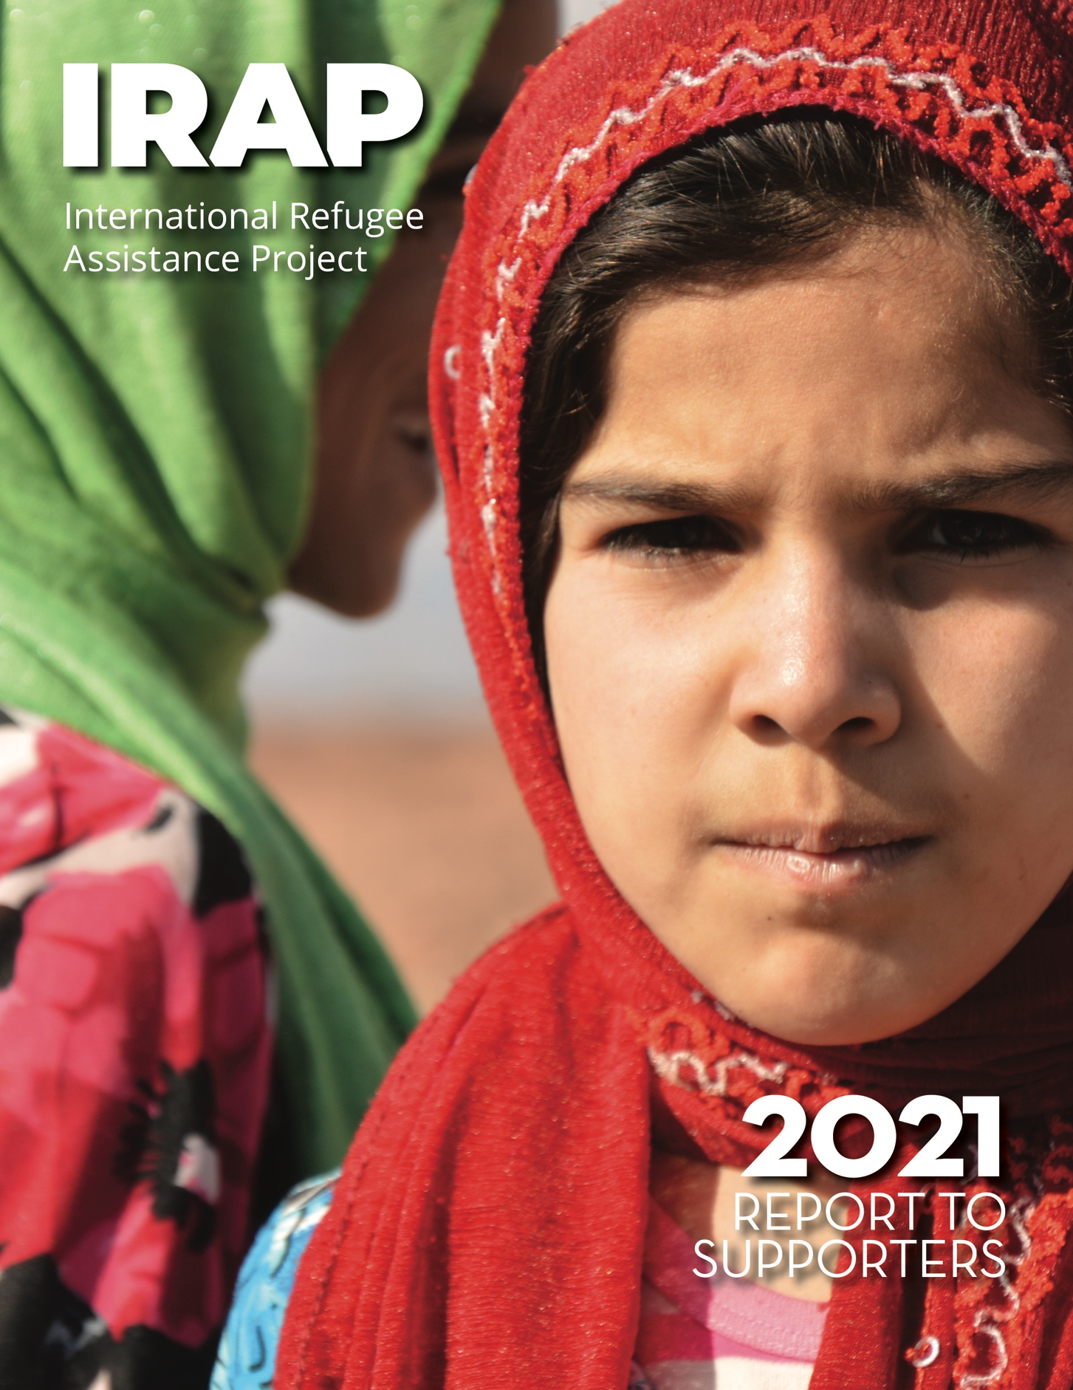

Copyright © 2021

International Refugee Assistance Project, Inc.
All rights reserved

Printed in the United States of America

www.refugeerights.org

Cover photo credit via Flickr: EU/ECHO Pierre Prakash

Note: The content of this Report is current as of September 2021.
For the security and privacy of clients, some of the names in
this Report have been altered or omitted.
Table of Contents
Letter from the Executive Director 3-4
Our Impact 5
Action for At-Risk Afghans 6-8
Helping to Reunite Separated Families 9-10
Rebuilding and Expanding U.S. Resettlement 11-12
Supporting Asylum Seekers 13-14
Developing Climate Displacement Protections 16
Our Supporters 17-18
Law School Chapters 19
Pro Bono Partners 20
Board of Directors and Advisory Board 21
IRAP, Inc. Fiscal Year 2021 Financials 22
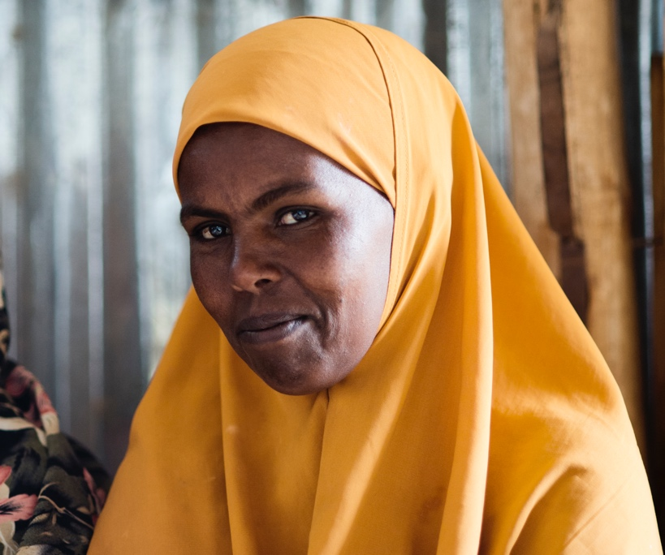
Photo Credit: WFP/Giulio d’Adamo

Letter from the Executive Director

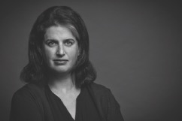

Dear IRAP Community,

The past year has been one of global change, but IRAP has remained steadfast in our commitment to empowering displaced people through direct legal services, litigation, and systemic advocacy. Through political uncertainty and turmoil, extreme weather events that profoundly disrupted peoples’ lives, and the ongoing impact of the COVID-19 pandemic, IRAP continues to approach our work with determination and creativity so that refugees can live safe, dignified lives, no matter the circumstances.

We were devastated to witness the haphazard and chaotic evacuation of U.S. government employees and other at-risk Afghans during the U.S. troop withdrawal from Afghanistan, which left many individuals and families in peril. During the evacuation period, our team worked around the clock to help as many people as possible reach safety through direct legal aid, and we leveraged systemic advocacy and strategic communications to hold the government accountable to its promises to provide refuge to its Afghan partners. We continue fighting for those who were left behind, including pushing for urgently needed new and expanded pathways to safety for Afghans. We are grateful to you for supporting our emergency response efforts and standing with our Afghan clients throughout their long journeys ahead.

In the United States, the present time is a historic moment of possibility to advocate for an improved and expanded U.S. refugee resettlement program. We are taking a leading role in helping to shape refugee policies and practices for years to come, while holding the new administration accountable for its promises to welcome refugees and migrants and treat them with dignity. At the same time, we continue to strategically grow our global programmatic work and geographic reach in order to remove the barriers that displaced people face on their journeys to safety around the world.

This year, we are excited to have formally registered IRAP Europe and opened a new office in Berlin, Germany, which serves as the hub for IRAP’s work assisting refugees seeking pathways to safety in Europe and enhances the capacity of our legal staff in Jordan, Lebanon, and the United States.

We recognize that responsible growth requires increased staff support and we are investing in our global team, with special thanks to our colleagues in our Operations and IT departments, who have enabled IRAP’s legal advocacy to continue seamlessly even as we remain physically apart due to COVID-19. Our IRAP remains strong and adaptable. All staff are participating in a comprehensive strategic planning process – our first ever – to ensure that our growth is scalable, sustainable, and informed by the needs expressed by displaced people themselves. As part of this effort, we launched a new Monitoring and Evaluation department to measure and evaluate our impact and enhance our use of data to guide our programming and strategy. By elevating and centering the voices of clients through this work, we seek to ensure that program development is driven, first and foremost, by the priorities of the people we serve.

IRAP is committed to living our values as a more diverse, equitable, and anti-racist organization, and we recognize that racial and social injustice lie at the root of human displacement. Over the past year and a half, our staff around the globe have been engaged in a long-term Diversity, Equity, Inclusion, and Accessibility (DEIA) effort to identify areas for organizational improvement – both internally and externally – and enact meaningful, durable solutions. We are ensuring that these priorities are reflected throughout our strategic plan and IRAP’s work globally, as part of our collective responsibility for justice.

As we look ahead, we remain dedicated to standing with displaced people, elevating their voices, and pursuing innovative solutions through a refugee-centered approach, so that all people can have a safe place to call home. It is with gratitude to our community of supporters and optimism for tomorrow that we continue the privilege of this work.

Sincerely,
Becca Heller
Executive Director
International Refugee Assistance Project
“IRAP continues to approach our work with determination and creativity so that refugees can live safe, dignified lives, no matter the circumstances.”

Photo Credit: Enzo Lenze

Our Impact

This past year, IRAP leveraged its global virtual law firm to provide direct legal assistance to a total of 3,627 individuals from 47 different countries. The clients we served include*:

40% U.S.-affiliated Afghan and Iraqi allies
20% Survivors of violence or torture
20% Medically vulnerable people
18% Unaccompanied or at-risk children
17% Survivors of sexual and gender-based violence and at-risk women
8% Persecuted LGBTQIA+ people

8% People facing religious persecution
943 clients were separated families seeking reunification.

85% of cases IRAP represented had a positive outcome, which includes resettlement, family reunification, and other legal benefits.**

*Client risk factors may intersect
**Outcomes are based on a sample of refugee cases with full legal representation from IRAP, where the case reached a known final resolution in fiscal year 2021.

Actions for At-Risk Afghans
For the past decade, IRAP has been a persistent voice calling on the United States government to protect its Afghan allies. When the Biden Administration first announced its withdrawal timeline in April 2021, we immediately advocated for a prompt, organized evacuation and ramped up our direct legal services and systemic advocacy for U.S.-affiliated Afghans seeking safety.

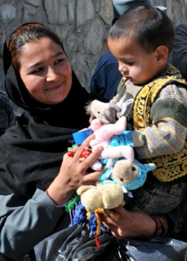
Photo Credit: U.S. Navy / Eric Lockwood
Actions for At-Risk Afghans
> Emergency Response: Evacuation to Safety
When last minute evacuation efforts finally began and the withdrawal deadline neared, chaos erupted at the Kabul airport as individuals sought immediate pathways to safety.
We launched into action to help as many Afghans as possible through an extraordinary response effort, while simultaneously holding the U.S. government accountable — through litigation, strategic communications, and advocacy — for the promises it had made to its allies.
IRAP launched a rapid response team to maintain a vital hub for trustworthy information to help Afghans in danger. Working 24/7, the team curated accurate, up-to-date information for our legal resources website that received over 60,000 pageviews in August; responded to urgent email requests daily; and advised countless lawyers and partner organizations. We also deployed a successful communications campaign urging the United States to continue evacuation efforts to the last possible moment that resulted in 155 media hits in major publications, increasing the footprint of our advocacy and mobilizing the community to pressure the Administration to evacuate as many at-risk Afghans as possible.
Our teams worked tirelessly to provide critical legal aid to our 574 current clients in Afghanistan seeking sanctuary. When evacuations officially ended on August 31, 139 IRAP clients had made it out safely, and we continue working closely with clients who remain in Afghanistan to inform them of their options as the situation evolves.
Our systemic impact teams also worked on multiple fronts to ensure that the United States did not abandon its Afghan allies. In July 2021, Congress passed an emergency bill making 8,000 additional Special Immigrant Visas (SIV) available, providing a pathway to safety for an estimated 32,000 Afghan allies and their families, due in large part to IRAP’s advocacy. The bill expedites the SIV process and expands protections for surviving spouses and children of slain applicants, among other procedural changes recommended by IRAP. In August 2021, our advocacy led the Administration to create a Priority-2 refugee resettlement category for certain at-risk Afghans who do not qualify for the SIV program, such as U.S.-affiliated journalists and nonprofit workers, allowing those eligible for this category access to U.S. resettlement.

Actions for At-Risk Afghans

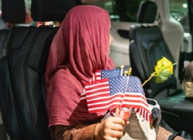
Photo Credit: Alan Nguyen / Combined Arms
CLIENT Story:
Mohammad, Naimah, and Khan*

In early 2021, Mohammad*, a husband and father of six, was assassinated by the Taliban in front of his ten-year-old son in retaliation for his work with the United States in Afghanistan. At the time of his murder, Mohammad had been waiting more than a decade to receive a Special Immigrant Visa.
His widow, Naimah*, knew that if she did not get out of Afghanistan immediately, she and her children would meet a similar fate. IRAP staff, alongside supporters, partner organizations, and members of IRAP’s Touro Law Center chapter, successfully advocated for the family to receive humanitarian parole in the United States, where they now live safely.
However, when the U.S. troop withdrawal from Afghanistan began and the Taliban took control of the country, Mohammad’s brother-in-law, Khan*, who had also worked for the United States, and his family were still in Kabul. IRAP lawyers were able to secure the family’s visas just in time, and Khan and his family were among the lucky ones able to get on an evacuation flight to join Naimah in the United States.
*Names have been changed to protect client identity

Actions for At-Risk Afghans

We are now preparing for the long road ahead, in anticipation of the protracted displacement of Afghan people.
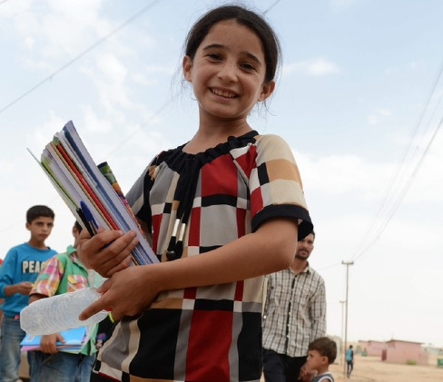
Photo Credit: Crown Copyright / Georgina Coupe

Our litigation team also filed groundbreaking emergency petitions for protection with the U.S. Department of State on behalf of all Afghan applicants in the SIV program, demanding the U.S. government fulfill its legal obligation to protect allies by evacuating them and their families to safety immediately. This was the first time the Department of State had been formally petitioned to exercise its statutory duty under the Afghan Allies Protection Act, which requires it to protect SIV applicants when they are in “imminent danger.”
Actions for At-Risk Afghans
IRAP’s attorneys, working with our pro bono network, will provide expert legal aid to all clients in harm’s way and assist those who got out on their journey to secure permanent legal status. Our team remains dedicated to helping Afghans— including those airlifted to the United States, those in third countries, and those still in Afghanistan— access their legal rights and pathways to safety.
IRAP is committed to being the most reliable and comprehensive source of legal information for Afghans seeking safety. We are continuously updating our legal resources website and providing Afghanistan-related legal trainings and tools to our partners.
In the United States, we are pushing for a bill that would secure resettlement benefits for Afghans who were evacuated without refugee status, and a bill to fast track their pathway to a green card. We are also advocating for a critical provision to enable evacuees in third countries to be granted entry into the United States while their applications for legal standing are pending. Additionally and critically, we are protesting inhumane detention conditions in third countries.
IRAP also filed a new lawsuit challenging the unlawful denial of an Afghan client’s ability to access the SIV program, after his letter of support from a U.S. supervisor could not be re-verified because the supervisor had been kidnapped by the Taliban. Efficiency and accountability are critical to a fair SIV process, and this challenge stands to benefit the tens of thousands of Afghan SIV applicants who must navigate complex and opaque procedures for accessing the SIV program.
The path ahead for Afghan refugees is likely to be arduous, but we are prepared and proud to stand as their steadfast legal advocates on their journeys to safety.
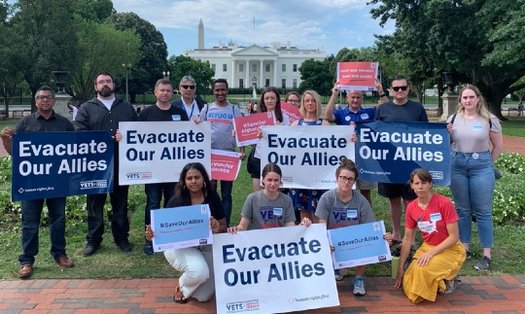
Photo Credit: LIRS
Helping to Reunite Separated Families
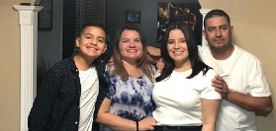
Client Story:
Ofelia*
When Valentina* was a young child, her mother, Ofelia,* made the difficult decision to leave her in the care of relatives in El Salvador while Ofelia sought a better future for her family in the United States.
In 2016, after a years-long costly process, Valentina was finally approved to travel to the United States to join her mother under the Central American Minors (CAM) parole program, which was designed to help children from Honduras, Guatemala, and El Salvador reunite with family in the United States without undertaking a perilous overland journey.
However, while she was waiting to travel, the Trump Administration abruptly terminated the CAM parole program, leaving separated family members like Ofelia and Valentina in limbo.
Ofelia joined IRAP’s lawsuit with co-counsel Arnold & Porter Kaye Scholer LLP, which challenged the CAM parole termination and resulted in a settlement allowing over 2,700 approved children and their families to reunite in the United States. After a hard-fought battle, Ofelia and Valentina are finally together again.
To date, over 1,500 beneficiaries of our CAM lawsuit have traveled or been cleared for travel to the United States.
IRAP’s policy advocacy was instrumental in the Biden Administration’s recent decision to restart and expand the CAM program, and we will continue to assist previous applicants who can benefit from the settlement, as well as provide support to new applicants.
*Names have been changed to protect client identity
Helping to Reunite Separated Families
Hundreds of thousands of displaced people may be eligible for complementary pathways to safety, like family reunification, that fall outside of traditional refugee resettlement processes. However, these pathways are often difficult to access due to complex legal, documentation, and financial requirements. Our legal team helps separated families around the world reunite in safe third countries and prevents families from being separated in the first place.
> IN EUROPE, our new office in Berlin, Germany serves as the operational base for our work with refugees seeking to reunite with family or seeking refuge from danger. Staffed with lawyers expert in the laws of European resettlement countries and complementary pathways to safety, IRAP Europe is establishing partnerships to assist displaced people as they navigate each country’s unique set of regulations.
We work with the United Nations High Commissioner for Refugees (UNHCR) and RefugePoint to provide direct legal services to separated families and initiate litigation to challenge structural barriers that keep families apart. Through this partnership, we provide family reunification-related assistance for pathways to Germany, Sweden, France, the Netherlands, Belgium, Norway, Switzerland, and the United Kingdom. Focusing on representation of unaccompanied refugee children, we have assisted 376 individuals as they seek to reunite with loved ones.
We also work with Equal Rights Beyond Borders in Greece to provide direct legal services and litigation representation to families separated within Europe. Through this collaboration, more than 110 lawsuits have been filed in Germany to challenge decisions keeping families apart, with more than 75% of cases resulting in positive outcomes for the families.
> IN THE MIDDLE EAST our offices in Jordan and Lebanon, two of the top refugee-hosting countries worldwide, are critical hubs for providing legal and humanitarian assistance to displaced people, including reuniting separated families. Our staff’s expert knowledge of the region and its legal landscape, combined with their own experiences living and working where our clients are based, enriches their understanding of the challenges facing displaced people in Jordan and Lebanon, and facilitates collaboration with local community-based organizations.
> IN THE UNITED STATES, we are providing direct legal services to help reunite separated families, litigating in federal court to ensure that family reunification programs for refugees are
Helping to Reunite Separated Families
made more efficient and equitable, advocating for the full inclusion of same-sex couples under these programs, and hosting clinics with our student chapters to help resettled refugees become citizens, which expands their options for family reunification.
In October 2020, IRAP launched a federal lawsuit on behalf of two resettled Darfuri refugee fathers who have been unable to bring their families abroad to the United States due to excessive bureaucratic delays in the Follow-to-Join process. This family reunification program nearly ground to a halt under the Trump Administration, leading to egregious delays and backlogs. IRAP also issued a report in March 2021 urging the Biden Administration to address unreasonable delays in the Follow-to-Join process and providing recommendations for promptly reuniting separated families.

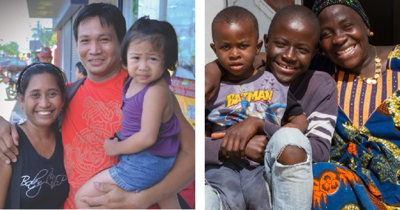
Photo Credit: IOM / Alan Motus Photo Credit: Sybille Desjardins

Rebuilding and Expanding
U.S. Resettlement

Under the Biden Administration, IRAP is taking a leading role in advocating for improved and expanded pro-refugee policies to re-establish the United States as a global leader in refugee protection and resettlement.
Client Story:
Majidah*
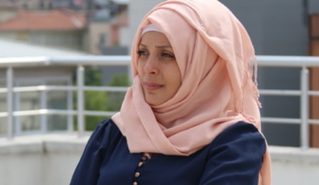
Photo Credit: UN Women / Sinem Aydin Lopez
Majidah*, her husband, and their four children, were forced to flee their home in Syria when armed conflict erupted in their community. After arriving in Jordan, they learned they had left not a moment too soon; their home had been destroyed by bombs. Without authorization to live in Jordan, the family could not access the UNHCR resettlement process and other critical resources, and lived in fear of being deported back to Syria.
Staff in IRAP’s Jordan office collaborated with a pro bono partner to help the family reunite with Majidah’s sister Asma*, a U.S. citizen. In May 2021, the family was approved for their I-130 visas to the United States.
Our offices in Jordan and Lebanon provide critical legal services to displaced people seeking lasting refuge in the United States.
*Names and photo have been changed to protect client identity
We are advocating for high refugee admissions numbers and more equitable, humane pathways to safety in the United States to reverse the near-shutdown of refugee resettlement during the Trump era. At the same time, we are encouraging the U.S. government to push other governments to improve their policies on refugee protections and build strong global humanitarian systems.
We are proud that many of our recommendations and advocacy priorities have been incorporated into the Biden Administration’s agenda.
On January 20, 2021, President Biden rescinded the Muslim and African bans, discriminatory policies put into place by the Trump Administration that banned individuals from certain majority-Muslim and African countries from entering the United States. IRAP had challenged these xenophobic policies through litigation and advocacy, and the rescission of these bans is a meaningful step toward the reversal of discriminatory Trump-era immigration policies.
IRAP played a leading role in shaping the priorities of the first-ever refugee rights Executive Order, signed into law on February 4, 2021, signaling a dramatic improvement in the U.S. government’s approach to welcoming refugees and migrants.
At the same time, we are holding the Biden Administration accountable; when the White House postponed its decision to increase refugee admissions for fiscal year 2021, IRAP and other refugee organizations strongly denounced the delay. In response to the outcry, the Biden Administration finally raised the refugee admissions cap from its historic low of 15,000 to 62,500. We continue to maintain pressure on the Biden Administration, which has led to the administration’s announcement that it intends to raise the refugee admissions target for fiscal year 2022 to at least 125,000.
IRAP has also increased its capacity to engage at the state and local level, working with the Refugee Advocacy Lab and other coalition partners, to provide technical assistance and toolkits for advocates engaging with government officials on pro-refugee policies.
We are excited to have pivoted to an affirmative agenda to rebuild and expand pathways to safety in the United States, while continuing to advocate for government accountability and just, equitable policies toward displaced people at the federal, state, and local levels.
> Defending the integrity of the U.S. resettlement system
In January 2021, a federal appeals court upheld our victory in a legal challenge to a Trump-era Executive Order that would have given state and local governments the power to veto refugee resettlement in their jurisdictions. Alongside co-counsel Shearman & Sterling LLP, we defended the integrity of the U.S. refugee resettlement system and established strong precedent against any future attempts by states or localities to obstruct resettlement. Through our successful litigation and policy advocacy, we helped galvanize local commitment to refugee resettlement, which encouraged the Biden Administration to revoke the original Executive Order in February 2021.
> Supporting refugees through private sponsorship
IRAP, alongside a diverse coalition of partners, potential future sponsors, and supporters, is leading the development of a robust private sponsorship program in the United States. Private sponsorship expands resettlement opportunities and connects resettled refugees with civil society groups, businesses, religious institutions, and families, building community support for refugee resettlement.
In June 2021, IRAP published a report in partnership with Amnesty International USA and the Niskanen Center, offering recommendations to the government for a private sponsorship program designed with direct input from refugee communities, clearly-defined goals and outcomes, and which centers DEIA principles in its design and implementation.
Our advocacy has led the government to move forward with a pilot program in early 2022.
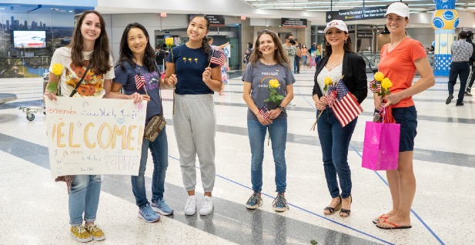
Photo Credit: Alan Nguyen / Combined Arms
Supporting Asylum Seekers
Client Story:
Rubén*

Facing political persecution, Rubén* fled Nicaragua to Mexico, but in Mexico, he was still not safe. He lived in fear of violence and discrimination for being gay and HIV positive. While trying to reach the U.S. border to seek asylum, Rubén was kidnapped and sexually assaulted. When he finally made it to the border, he was turned away under Title 42, a policy exploited by the Trump Administration and continued by the Biden Administration to turn away and expel asylum seekers en masse. Forced to return to Mexico and live in a shelter, Rubén continued to experience harassment and did not have reliable access to life-sustaining medical care.
IRAP staff sought an exception to Title 42 on Rubén’s behalf, and he was successfully granted humanitarian parole into the United States. Our partner, Miles for Migrants, covered the cost of his travel to New York City to reunite with his brother-in-law.
To date, IRAP has assisted with requesting exceptions to Title 42 on behalf of 274 individuals, to allow them to safely await processing of their asylum claims in the United States before U.S. Immigration Courts.
*Names and photo have been changed to protect client identity
Informed by the experiences of our clients and in partnership with the Catholic Legal Immigration Network (CLINIC)’s Estamos Unidos project, in the fall of 2020, IRAP launched a pilot program to provide remote legal advice, community education, and legal representation to people seeking asylum at the U.S. southern border’s Ciudad Juárez/El Paso port of entry.
Xenophobic policies such as the Migrant Protection Protocols (MPP) and the exploitation of Title 42 effectively closed the U.S. border to new asylum seekers and forcibly expelled asylum seekers with pending claims to precarious conditions in Mexico. As a result, thousands of people remain trapped abroad in inhumane conditions due to inequitable processes for continuing or reopening asylum claims.
We have represented 76 clients affected by these policies, helping clients to prepare asylum applications, learn the status of their asylum claims, and gain entry to the United States. IRAP’s work with clients also informs our litigation and advocacy work to address systemic barriers to justice for asylum seekers.
> PROTECTING ASYLUM SEEKERS’ RIGHT TO WORK IN THE UNITED STATES
In July 2020, IRAP, the Asylum Seeker Advocacy Project (ASAP), and Gibson, Dunn & Crutcher LLP challenged the Trump Administration’s efforts to prevent work authorization for asylum seekers. Without work authorization, asylum seekers are hindered from securing food, shelter, and medical care for themselves and their families. In September 2020, we were granted a preliminary injunction in this federal lawsuit defending asylum seekers’ right to work in the United States, halting the exclusionary Trump-era rules for asylum seeker members of ASAP and CASA de Maryland while our case is pending in court. Our case stands to benefit an estimated 150,000 people annually.
> CHALLENGING ATTEMPTS TO DEPORT ASYLUM SEEKERS FROM
THE UNITED STATES
In October 2020, IRAP won a significant victory in our case with RAICES challenging Trump-era changes to the Credible Fear Interview process, the first step in seeking asylum at the U.S. border. The changes were designed to make it more difficult for asylum seekers to prove a credible fear of persecution. The court voided the government’s changes, ruling them unlawful, and IRAP is now monitoring the implementation of this ruling. Approximately 91,000 people stand to benefit from this case annually.
> ADVOCATING FOR RESOURCES AND PROTECTIONS FOR ASYLUM SEEKERS IN JORDAN AND LEBANON
IRAP advocates for the rights of asylum seekers worldwide, including for those whose first country of asylum is not a viable permanent home. Staff in our Jordan office fight to ensure that access to humanitarian assistance, like healthcare and financial support, is based on need, not nationality. We elevate the voices of displaced Iraqi, Yemeni, Sudanese, and Somali people awaiting relocation in Jordan, who are often not recognized as asylum seekers. These populations struggle to access humanitarian assistance even when they do have formally recognized claims because most assistance is designated for the Syrian displaced population in Jordan.
In Lebanon, amid an unprecedented economic crisis, political instability, and resource shortages, staff are working tirelessly to make sure vulnerable displaced people with asylum and refugee claims can access the services they need to survive. To meet the needs of our clients, many of whom are currently unable to purchase food or medicine, we have increased cash assistance and humanitarian referrals, while continuing to support clients in their efforts to relocate to countries of resettlement.

Photo Credit: Maritza Ríos /
Secretaría de la Cultura de la CDMX

IRAP Chatbot

Displaced people in the Middle East can access the IRAP Chatbot, designed to provide refugees with tailored information about their eligibility for multiple pathways to safety. Available 24/7, the chatbot reviews users’ information and refers them to legal assistance or our self-help website, which contains 150 legal guides in five languages.
Based on client feedback, we have expanded the chatbot’s function to make these legal resources even more accessible. The chatbot originally launched to provide assistance to Iraqi and Syrian users, and we have now expanded its usability to people across the Middle East. Users can now access the chatbot through Facebook Messenger and Telegram, and we rebranded the chatbot from “Mona” to the “IRAP Chatbot” to offer a depersonalized interface where users may feel more comfortable sharing sensitive information.
> THIS YEAR:
6,862 people used the IRAP Chatbot.
33,578 people accessed information on our self-help website.
1,340 chatbot users were referred to IRAP staff for additional screenings, intakes, and legal services.
Client Story:
Jawad*
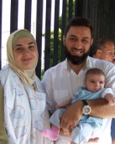
In 2019, Jawad*, a Syrian man and longtime permanent resident of the United States, reached out through our chatbot asking for help to reunite with his wife Zafirah* and daughter Rayya*. Jawad and Zafirah lived together in Turkey while he was studying for his Ph.D. in engineering and she was pregnant. When their visas were set to expire, Jawad had to return to the United States, but Zafirah and their infant daughter were unable to go with him or return to war-torn Syria. The chatbot referred the family for legal assistance, and IRAP helped Zafirah and Rayya prepare for their visa interview with the U.S. embassy in Turkey. IRAP assisted them in a visa waiver application to overcome the 2017 Executive Order banning Syrians from entering the United States, enabling the family to be reunited in the United States.
*Names and photo have been changed to protect client identity

Developing Climate Displacement
Protections

IRAP, in partnership with the Natural Resources Defense Council (NRDC), has launched its climate displacement work to develop and advocate for better protections and pathways to safety for people displaced by climate change.
People forced to move due to disasters and environmental degradation are one of the fastest-growing displaced populations in the world, with already-marginalized communities facing climate disasters on top of economic, health, and housing challenges. Yet, legal protections for these populations lag far behind the need. There are currently no multilateral treaties or domestic laws designed to protect climate-displaced people.
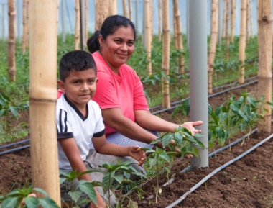
Photo Credit: FAO El Salvador / Oscar Mendoza
This year, the Biden Administration’s refugee rights Executive Order required U.S. agencies to report on the effects of climate change on migration and options for the resettlement and protection of climate-displaced people. We published recommendations to inform this interagency report and the Administration’s broader agenda, including recognizing climate-displaced people as refugees under the current U.S. refugee definition and broadening eligibility for Temporary Protected Status (TPS) to include people displaced by climate change.
Alongside 350.org and the ACLU of Southern California, we convened environmental, immigration, and refugee advocates to share knowledge, formulate strategies, and develop relationships across organizations. We continue to develop resources to build a community movement around climate displacement.
As climate change continues to make many places around the globe less habitable in the years and decades to come, the need for a comprehensive legal framework protecting climate migrants will become ever more important. By working to develop a collaborative, solutions-based framework now, IRAP seeks to proactively defend the rights of climate-displaced people and ensure that their right to live in safety is enshrined in the law.

Photo Credit: Peg Hunter

Our Supporters

IRAP extends profound thanks to our generous supporters this past fiscal year —September 1, 2020 to August 31, 2021.

$1,000,000+
Anonymous (2)
Open Society Foundations

$100,000-$999,999
Akin Gump Strauss Hauer
& Feld LLP
Anonymous (7)
Carnegie Corporation
of New York
Catena Foundation
Chan Zuckerberg Initiative
DAF, an advised fund of
Silicon Valley
Community Foundation
Democracy Fund
Ed and Barbara Shapiro
FJC — A Foundation of
Philanthropic Funds
Ford Foundation
FWD.us Education
Fund, Inc.
G. Barrie Landry
Levi Strauss Foundation
Mary Ann Stein
Open Philanthropy
Price Philanthropies
Foundation
Rachel and Mike Jacobellis
Robert J. Abernethy
Rockefeller Brothers Fund
Tali and Boaz Weinstein
Philanthropic Fund
The David Tepper Charitable
Foundation, Inc.
The Global Whole Being
Fund of RSF Social Finance
The Grove Foundation
The Hearthland Foundation
The Morningstar
Foundation
The Norris Family
Charitable Fund
The Peter and Patricia
Gruber Foundation
The Sigrid Rausing Trust
United Nations High
Commissioner for
Refugees

$50,000-$99,999
AIG
Anna and Carl Reisner
Anonymous (2)
Choose Love, Inc.
Dani and Stephanie Stern
Daniel Smith
Frederick Iseman
Hart Giving Fund
Jacob and Hilda Blaustein
Foundation
Morton K. and Jane
Blaustein Foundation
Unbound Philanthropy

$25,000-$49,999
Amed Khan
Anonymous (4)
Bryan Pellegrino
David and Patricia
Nierenberg
Dissent Pins
Khudairi Group
Catherine and Subhi
Khudairi
Microsoft
Paul, Weiss, Rifkind,
Wharton & Garrison LLP
Paulette Meyer and
David Friedman
Refugee Action Fund
Sheila E. Menz
The David Bohnett
Foundation
The Schocken Foundation
The Sparkjoy Foundation
United Nations Voluntary
Fund for Victims of Torture
Weil, Gotshal & Manges LLP
Zegar Family Fund

$10,000-$24,999
Ackerley Family Foundation
Anonymous (7)
ATK Foundation in memory
of Gul Mohammed Telwar
Bryan and Suzanna Altman
Cleary Gottlieb Steen &
Hamilton LLP
Dentons US LLP
Dr. Bronner’s Family
Foundation
Frances Posel
Freshfields Bruckhaus
Deringer
Gloria Principe and
John O’Farrell
Jacob Carnow
Jennifer and Tim Kingston
Kirkland & Ellis LLP
Latham & Watkins LLP
Michael and Dana Springer
Charitable Fund
Nardello & Co.
Orrick, Herrington
& Sutcliffe LLP
Skadden
Stempel Family Charitable
Fund at Fidelity Charitable
Susie Hwang and
Matt Glickman
Taketa ‘Ohana Fund 21
of the Hawai‘i Community
Foundation
The Altschul Foundation
The Morrison & Foerster
Foundation
The Resiliency Fund
The Tarang and Hirni Amin
Family Fund at Schwab
Charitable
Tikva Grassroots Empowerment Fund of
Tides Foundation
Tushar Shah and Sara Zion
Walt and Joy Cooper
Wellington Shields & Co.
LLC

$5,000-$9,999
Adam Sender
Allen & Overy
Anna Fuller Charitable Fund
Anonymous (12)
Arnold & Porter Kaye Scholer LLP
Arshaad Yar
Ashurst
Barinaga Goodman Fund of
West Marin Fund
Catbird
David and Hope Maltz Family Fund at Schwab
Charitable
DLA Piper LLP (US)
Duane Morris LLP
Elaine Nonneman
Elise Minter Konover
Gina Maya and Richard
Capelouto
Goldstein-Rogers Family
Fund at Fidelity Charitable
Greg Sharenow and Julie
Gersten
IAC
Intel Foundation
Jennifer Edwards
Jonathan Marcus and
Adrienne Brown
Katherine and Paul Stansifer
King & Spalding LLP
Linda and Peter Parshall
Linklaters LLP
Miriam Buhl
Nishit Mehta and
Farzana Curmally
Red Shutters Charitable Fund at Fidelity Charitable
Richard Yannow
Ryan Kass
Sheppard, Mullin, Richter
& Hampton LLP
Talbot Giving Fund, a donor
advised fund of Fidelity
Charitable
Taryn Higashi and Ivan
Zimmerman
The Justice and Joy Fund at
Vanguard Charitable
The Michie Family Fund
The New York Bar
Foundation
The Weil Family Foundation
The Wilson Sonsini
Goodrich & Rosati
Foundation
White & Case LLP
Zachary Silver and Tamara
Frankel Fund,
an American Endowment
Foundation Donor Advised
Fund

Law School Chapters

IRAP seeks to develop the next generation of legal advocates for refugees through our partnerships with law school student chapters.
Over the past year, our student chapters helped 40 clients apply for permanent residency or citizenship. Student chapter members have also conducted important research and outreach projects on climate displacement, the effects of state and local laws on refugees in the United States, the impact of COVID-19 on due process rights in immigration court, and more.
“One thing I’ve learned working on this case is just what an impact the existence of counsel can have on a refugee case. My work with IRAP has inspired me, after I graduate in May, to pursue a career in refugee and asylum law.”
— Rebecca Garfinkel, alum of University of Michigan IRAP chapter
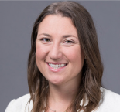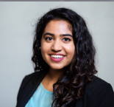

“Our work with IRAP has reinforced the importance of centering impacted communities and clients in both direct service and policy work. Through our time with IRAP, we have better understood the importance of ‘listening first.’ This helps ensure that our work is sustainable, and actually meeting community needs.”
— Suhayla Ahmed, co-leader of University of California at Berkeley IRAP chapter

Law School Chapters

American University Washington
College of Law
Boston University School of Law
Columbia Law School
Cornell Law School
City University of New York School of Law
Emory University School of Law
Fordham University School of Law
George Washington University Law School
Georgetown University Law Center
Harvard Law School
McGill University Faculty of Law
New York University School of Law
Northwestern University Pritzker School
of Law
Osgoode Hall School of Law
Rutgers School of Law
Seattle University School of Law
Stanford Law School
Touro Law Center
University of Alabama School of Law
University of California, Berkeley School
of Law
University of California, Irvine School
of Law
University of California, Los Angeles
School of Law
University of Chicago Law School
University of Connecticut School of Law
University of Michigan Law School
University of Pennsylvania Law School
University of Southern California, Gould
School of Law
University of Virginia School of Law
Yale Law School

Pro Bono Partners

In 2020, 1,968 law student and pro bono attorney volunteers provided over 16,000 hours of free legal aid, valued at over $10,800,000, to help displaced people seeking safety.
To honor the indispensable support our pro bono and student networks provide, IRAP celebrated its inaugural Pro Bono Appreciation Week, recognizing individuals, firms, case teams, and project teams with ten awards for their exceptional contributions.

“Working with IRAP over the past few years has been a wonderful experience. Throughout [our work together on] the Lautenberg matter, we have been able to secure meaningful results for our clients. I am ecstatic when I hear that refugees have been able to resettle in the United States, and of course we hope that the work that we’ve done makes it easier for refugees to obtain resettlement in the future.”
“Through working with IRAP, I’ve learned that refugees are not only those fleeing war-torn countries, but can also be religious minorities as well or anyone whose life is at risk because of oppressive conditions. And, as a son of an immigrant who left Central America because of political turmoil, ensuring equitable refugee admissions is something that is personally important to me.”
— Keith Williams, Latham & Watkins LLP, “Excellent Law Firm” award for IRAP’s 2021 Pro Bono Appreciation Week
CORPORATE PARTNERS
Pro Bono Partners

CORPORATE PARTNERS
The 3M Company
AIG
General Electric
Microsoft Corporation
Rosetta Stone
Starbucks
Synchrony Financial
LAW FIRMS
Allen & Overy
Alston & Bird LLP
Arnold & Porter Kaye Scholer LLP
Ashurst
Baker, Donelson, Bearman,
Caldwell & Berkowitz P.C.
Ballard Spahr LLP
Barasch McGarry Salzman
& Penson
Benesch, Friedlander,
Coplan & Aronoff LLP
Berry Appleman & Leiden LLP
Bradley Arant Boult
Cummings LLP
Brown Rudnick LLP
Bush Seyferth PLLC
Cleary Gottlieb Steen &
Hamilton LLP
Clifford Chance
Covington & Burling LLP
Davis Polk & Wardwell LLP
Davis Wright Tremaine LLP
Dentons US LLP
DLA Piper LLP (US)
Duane Morris LLP
Dykema Gossett PLLC
Faegre Drinker Biddle & Reath LLP
Fenwick & West LLP
Fragomen, Del Rey, Bernsen &
Loewy, LLP
Freshfields Bruckhaus Deringer
Gibson, Dunn & Crutcher LLP
Goodwin Procter LLP
Goulston & Storrs P.C.
Greenberg Traurig, LLP
Hengeler Mueller
Hogan Lovells
Holwell Shuster & Goldberg LLP
Hughes Hubbard & Reed LLP
Hunton Andrews Kurth LLP
Jenner & Block
K&L Gates LLP
Kilpatrick Townsend &
Stockton LLP
King & Spalding LLP
Kirkland & Ellis LLP
Koskie Minsky LLP
Latham & Watkins LLP
Law Offices of Carl G. Roberts
Linklaters LLP
Littler Mendelson P.C.
Lowenstein Sandler LLP
Moore & Van Allen PLLC
Morgan Lewis & Bockius LLP
Neal, Gerber & Eisenberg LLP
Nixon Peabody LLP
Orrick, Herrington & Sutcliffe LLP
Parker, Hudson, Rainer &
Dobbs LLP
Patterson Belknap Webb &
Tyler LLP
Paul, Weiss, Rifkind, Wharton
& Garrison LLP
Poles, Tublin, Stratakis &
Gonzalez, LLP
Polsinelli LLP
Proskauer Rose LLP
Reed Smith LLP
Ropes & Gray LLP
Rosenstock Legal Services
Schadbach Rechtansanwälte
Schiff Hardin LLP
Seyfarth Shaw LLP
Shearman & Sterling LLP
Sheppard, Mullin, Richter
& Hampton LLP
Sidley Austin LLP
Simpson Thacher & Bartlett LLP
Skadden, Arps, Slate, Meagher
& Flom LLP
Steptoe & Johnson LLP
Sullivan & Cromwell LLP
The Legal Project
Three Crowns
Venable LLP
Watson Farley & Williams LLP
Weil, Gotshal & Manges LLP
White & Case LLP
Whiteman Osterman &
Hanna LLP
Wilson Sonsini Goodrich & Rosati
Winston & Strawn LLP
Youman, Madeo & Fasano, LLP

Board of Directors and Advisory Board
Board of Directors
Robert J. Abernethy, President, American Standard Development Company and Self Storage Management Company; Managing Director, Metropolitan Investments, LLC
Ahilan Arulanantham, Professor from Practice and Faculty Co-Director of the Center for Immigration Law and Policy, UCLA School of Law
Miriam Buhl, Pro Bono Counsel, Weil, Gotshal & Manges, LLP
Joe Cerrell, Managing Director, Global Policy and Advocacy, and Interim Director, Development Policy and Finance, Bill & Melinda Gates Foundation
Mazen Darwish, Founder and Director, Syrian Center for Media and Freedom of Expression
Taryn Higashi (Board Chair), Executive Director, Unbound Philanthropy
Mike Jacobellis, Chief Investment Officer, New Holland Capital
Amed Khan, Founder, Elpida Home; Founder and President, Zaka Khan Foundation
Subhi Khudairi, Founding Managing Partner and President, Khudairi Group
Michael Madnick, CEO, Mountain Philanthropies
Carl Reisner, Co-Head of Mergers and Acquisitions, Paul, Weiss, Rifkind, Wharton &
Garrison LLP
Zainab Salbi, Founder of Women for Women International, Media Host, and Best-Selling Author
Edward Shapiro, Managing Trustee, The Shapiro Foundation; President, Shapiro Investment Company, LLC
Tali Farhadian Weinstein, Prosecutor, Professor, and Criminal Justice Reform Advocate
Advisory Board
Michael Breen, President and CEO, Human Rights First
Walt Cooper, Head of Innovation, Walmart Health
Stephanie Cornell, Managing Director, Draper Richards Kaplan Foundation
Lara Finkbeiner, Public Interest Director, University of Michigan Law School
Patricia A. Gruber, Peter and Patricia Gruber Foundation
Jill Iscol, President, IF Hummingbird Foundation
Zach Iscol, Executive Director, Headstrong Project; Founder and CEO, Hirepurpose
Steven M. Miska, Founder, SLC Consulting, Inc.; Colonel (Retired), U.S. Army
Alex O’Neill, Associate, Harvard Kennedy School; Graduate Student, University of Oxford
John Oliver, Comedian and Host of HBO’s Last Week Tonight with John Oliver
Robert Raben, President and Founder, The Raben Group
Abbas Ravjani, Privacy and Public Policy Manager, Facebook
Neal Rickner, Managing Partner, Elevation Ventures
Thomas A. Russo, Executive Vice President and General Counsel, Legal, Compliance, Regulatory Affairs & Government Affairs, (Retired), American International Group, Inc.

IRAP, Inc. Fiscal Year 2021 Financials

We are grateful for our generous supporters who make our work possible. Together, we will continue delivering legal solutions for forced migrants and defending and expanding the rights of displaced people through legal advocacy.

Expenses
$12,403,759
86.9%
on Programs
Legal Services 53%
Litigation 15.9%
Policy 8.8%
Communications 5.6%
Other (Climate Displacement, Legal
Strategy, Monitoring & Evaluation) 3.6%

7.1%
on FUNDRAISING

6%
on MANAGEMENT

REVENUE
$18,525,139
37.7%
Foundation Contribution Income
50.7%
Individual Contribution Income
6.4%
Corporate Contribution Income

5.2%
Interest & Other Income

The International Refugee Assistance Project is an independent 501(c)(3) nonprofit organization committed to transparency and accountability. At the time of this report’s publication, IRAP is undergoing our annual audit, to be completed in late 2021. As such, these graphs reflect unaudited financial numbers. Upon completion, IRAP will publish the independently-audited financial statements for the fiscal year which ended August 31, 2021, along with IRAP’s 990 filings, on our website.

