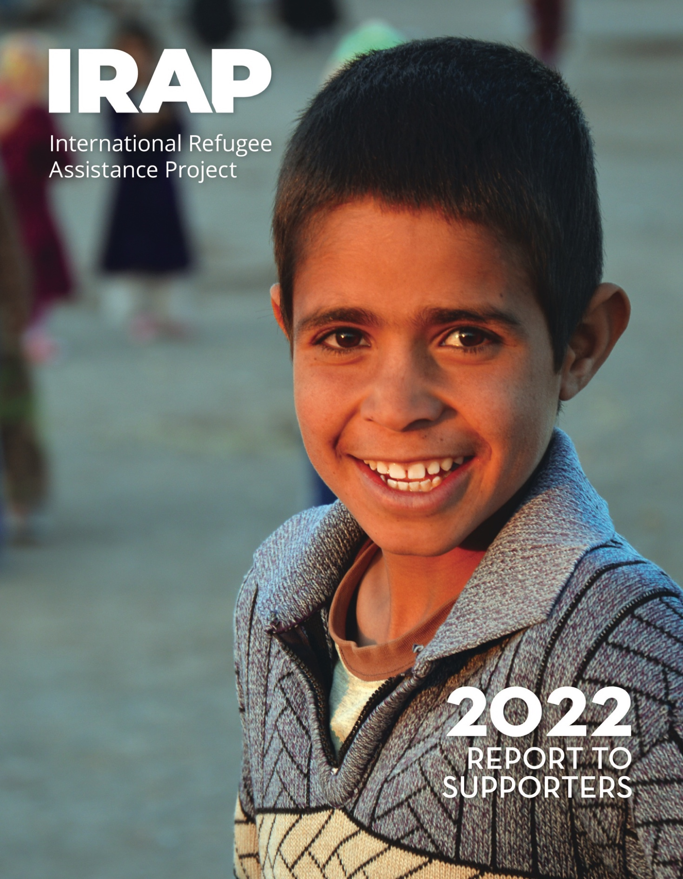

Copyright © 2022

International Refugee Assistance Project, Inc.
All rights reserved

Printed in the United States of America
www.refugeerights.org
Cover photo credit: Pierre Prakash
Note: The content of this Report is current as of September 2022.
For the security and privacy of clients, some of the names in this Report have been altered or omitted.

Table of Contents
Letter from the Executive Director 3-4
Our Impact 5
Action for At-Risk Afghans 6-8
Helping to Reunite Separated Families 9-10
Rebuilding and Expanding U.S. Resettlement 11-12
Supporting Asylum Seekers 13-14
Developing Climate Displacement Protections 16
Our Supporters 17-18
Law School Chapters 19
Pro Bono Partners 20
Board of Directors and Advisory Board 21
IRAP, Inc. Fiscal Year 2021 Financials 22
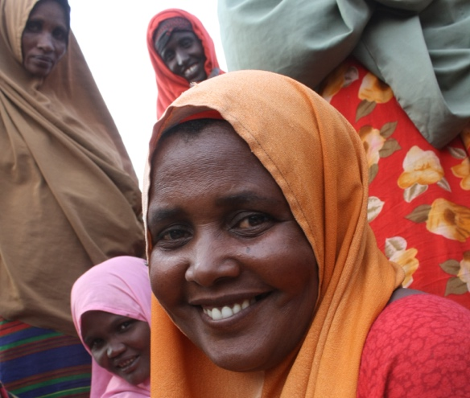
Photo Credit: WFP/Giulio d’Adamo

Letter from the Executive Director

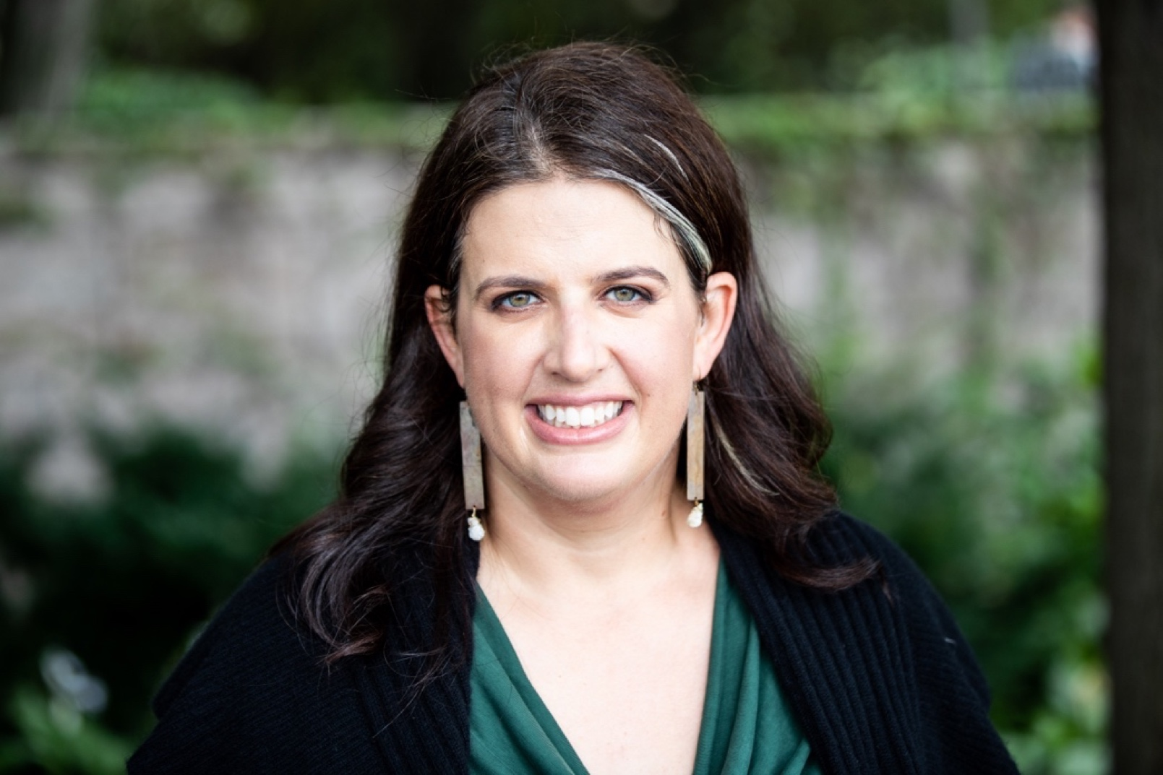
Photo Credit: John D. and Catherine T. MacArthur Foundation
Dear IRAP Community,
Over the past year, the number of people experiencing displacement reached a record 100 million worldwide, underscoring the urgent need for innovative, scalable legal solutions for people seeking safety. IRAP works to ensure not only that these solutions exist, but that displaced people around the world can access them equitably. The global welcome extended to displaced Ukrainians this year demonstrates that countries can efficiently welcome displaced populations, quickly and at scale, when the political will is there. IRAP believes that all people should have the same opportunity to reach safe refuge and live with dignity.
Through legal aid and information, impact litigation, policy advocacy, strategic communications, and partner capacity-building, we are working toward a world where every person experiencing displacement is empowered to know their legal rights, access safe migration pathways, and catalyze fairer and more humane refugee and immigration systems.
We are holding the U.S. government accountable for its ongoing obligations to U.S.-affiliated Afghans. At the same time, we are leading global efforts to facilitate family reunification as a key pathway to safety, especially for children who have been separated from their parents. We are also expanding our legal assistance to new parts of the world, clearing the way for migrants to activate their rights and enact systemic improvements, and spearheading efforts to develop legal protections for people displaced by the climate crisis.
This year, after a rigorous due diligence process, IRAP was selected as one of only nine organizations to comprise the 2021-2022 cohort of The Audacious Project, a collaborative funding initiative housed at TED that enables organizations to pursue bold solutions to the world’s most urgent challenges. This honor makes possible a growth project, developed in tandem with IRAP’s recently-finalized five-year strategic plan, that encompasses building out the world’s most robust and accessible virtual legal information platform for displaced people, investing significant resources into capacity-building for frontline partners, and extending our presence, partnerships, and systemic change work to regions hosting 75% of the world’s refugees. These project components will help us serve 2.5 million forced migrants worldwide by 2027.
We have laid the groundwork for this growth, establishing a sophisticated new legal case management database and undertaking a multiphase needs assessment to identify areas for IRAP’s geographic expansion. We are also building out IRAP’s infrastructure in ways that systematically integrate equity considerations into our business practices and ensure that our programs and staff have the support necessary for success. We recognize that an inclusive, high-trust workplace is essential for sustained, collaborative progress toward our goals.
More broadly, we view the principles of diversity, anti-racism, and global justice as foundational to our mission. By collaborating with our clients to address inequities in forced migrants’ access to legal solutions, we seek to combat injustice while elevating the agency and dignity of people experiencing displacement and marginalization.
With forced migration rising, we remain committed to ensuring that everyone can have a safe place to live and a safe way to get there. We are grateful to the community of supporters who make the privilege of our work possible, and to the clients who trust us to advocate alongside them.
Sincerely,
Becca Heller
Executive Director
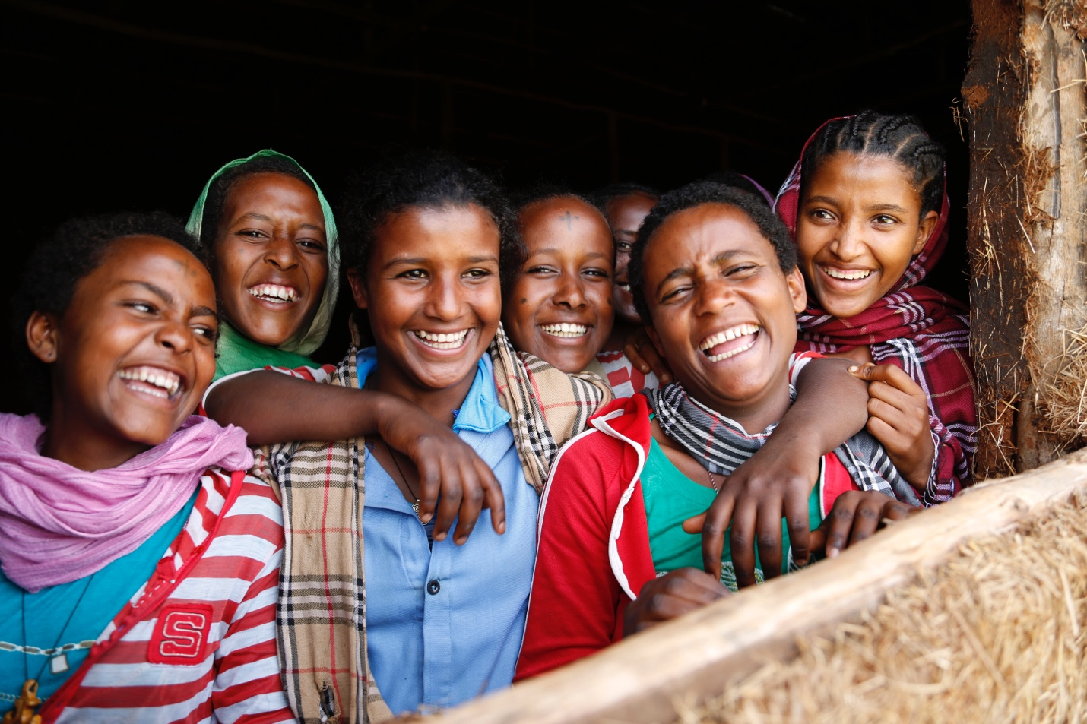Photo Credit: Jessica Lea/DFID

Our Impact

This past year, IRAP provided legal assistance to a total of 4,354 clients from 52 countries.

The clients we served include*:

53% U.S.-affiliated Afghans and Iraqis and their families
1,130 Afghan clients assisted during and following the U.S. withdrawal from Afghanistan.
17% Survivors of sexual and gender-based violence and at-risk women
7% People facing religious persecution
21% Unaccompanied or at-risk children seeking to reunite with their families
12% Asylum seekers at the U.S.-Mexico border, including people with disabilities and additional populations who are marginalized or are underserved by legal aid
14% Survivors of torture and other violence

6% LGBTQIA+ people experiencing persecution
12% people with medical vulnerabilities
*Client risk factors may intersect
856 clients were separated families seeking reunification.
79%* of cases IRAP represented had a positive outcome, which includes resettlement, family reunification, and other legal benefits.

*Percentage of positive outcomes among cases with known outcomes.
Our Impact
IRAP is a global leader in equipping displaced people with legal resources to know, activate, and unlock their legal rights.

Since IRAP’s founding in 2008:
IRAP has provided legal aid to more than 40,000 clients from over 100 countries.
IRAP’s legal information website, offering self-help legal resources in multiple languages, has been visited by nearly 204,000 people since it was launched in 2019.
More than 29,400 people have used IRAP’s chatbot to access tailored information about their eligibility for pathways to safety – and connect with staff when we can offer legal assistance – since it was created in 2019.
IRAP’s litigation in U.S. courts has benefitted, and stands to benefit, more than 493,000 displaced people and their families.
IRAP’s policy advocacy has protected and expanded pathways to safety in the United States for approximately 370,000 people.

IRAP has built a network of more than 6,300 pro bono attorneys and student volunteers advocating for refugees’ rights.
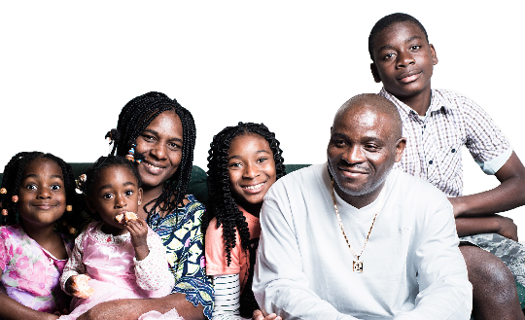
Photo Credit: Indrek Torilo

Collaborating with Clients and Partners to Guide Our Priorities
IRAP’s priorities are guided by insights gleaned from our clients’ own lived experiences as well as from our partners working with displaced populations around the globe. By providing legal aid and information directly to displaced people, IRAP is also able to identify patterns of injustice and gaps in information and services, allowing us to tailor our programming to address the needs of displaced populations as expressed by displaced people themselves.
Clients direct the goals of their legal representation, provide formal feedback to strengthen our work, and inform all stages of our legal services and advocacy. Our role as advocates is to empower our client populations to construct their own solutions to challenges by providing them with legal assistance, information, and options, as well as referrals to vital humanitarian services that fall outside the scope of IRAP’s work. Furthermore, we work to bring about large-scale systemic reforms by partnering with clients and amplifying their voices through strategic communications, policy advocacy, and impact litigation.
For example, IRAP works with families eligible for the Central American Minors (CAM) Refugee and Parole Program, which enables children at risk in El Salvador, Guatemala, and Honduras to reunite safely with their parents in the United States. Two of our CAM clients are participating in IRAP’s ongoing litigation with co-counsel Haynes & Boone LLP to keep this vital pathway for family reunification in the United States open, and another CAM client engaged in media advocacy with us to highlight the importance of the program. By collaborating with IRAP to share their lived experiences with the court and media, our clients are powerfully conveying how the program benefits separated families.
Furthermore, IRAP works with hundreds of partners — including many refugee-led and community-based organizations — who refer potential clients to us, provide additional support services, and serve as allies for systemic change. Through this network, we also refer our clients to organizations that can connect them with vital humanitarian resources such as medical services, mental health care, and housing assistance.
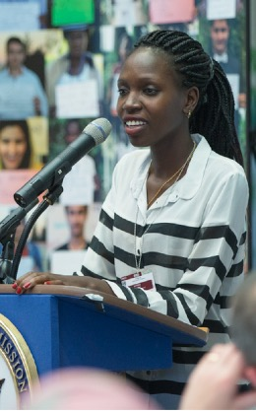
Photo Credit: United States Mission Geneva


Photo Credit: UN Photo / Evan Schneider

Collaborating with Clients and Partners
to Guide Our Priorities
Our humanitarian referral process is especially robust in Lebanon, which hosts one of the largest displaced populations in the Middle East, and where political and economic instability have increased the need for humanitarian assistance among refugee and host communities alike. By closely tracking clients’ service referrals, IRAP’s dedicated humanitarian assistance staff in Lebanon is able to assess whether clients may have a stronger case for certain resettlement programs, such as those that prioritize people with significant medical needs. This highly personalized follow-up helps ensure that clients’ basic needs are met to the extent possible in Lebanon, while providing evidence for the urgency of their cases for resettlement in other countries. Whether we are providing direct legal services, connecting clients with wraparound resources, or advocating for systemic improvements to safeguard the rights of displaced people around the world, IRAP’s work is guided by close collaboration with the individuals we serve and members of refugee and host communities.
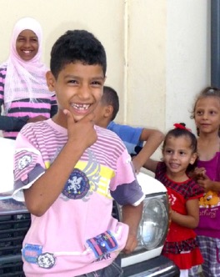
Photo Credit: Luciano

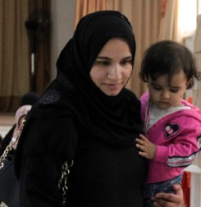
Photo Credit: Ministry of Foreign Affairs of the Republic of Poland
CLIENT Story:
Al Nabolsi Family

The Al Nabolsi family are Syrians living in Lebanon. Both parents are survivors of extreme violence and torture, and one of the children — a two-year-old girl — has multiple, severe medical vulnerabilities, including a birth defect and paralysis in her legs. The family has also had difficulty finding safe housing in Lebanon. While providing legal services to the family, IRAP referred them to the Lebanese Center for Human Rights for medical services, including psychological care for the parents and physiotherapy for the child. We also referred them to the humanitarian organization, Caritas, for housing and emergency cash assistance.
Combined, these efforts not only help meet the family’s urgent needs, but also result in important documentation of their precarious medical and living situation for their resettlement application. We continue to both advocate for their safe resettlement in another country and collaborate with partners in Lebanon to help ensure they have access to the services they need to live in health and dignity while seeking lasting refuge.
*Photo changed to protect client identity

Mobilizing Legal Resources in
Displacement Crises
IRAP’s expertise helps us anticipate displacement emergencies and prepare for their impact through policy advocacy and legal resource development. We can then apply our innovative service delivery model to the specific circumstances of each crisis situation, disseminating critical legal information and calling for systemic solutions.
After the Biden administration announced its timeline for withdrawal from Afghanistan in April 2021, we leapt into action to help U.S.-affiliated Afghans facing threats from the Taliban reach safety, drawing upon our decade-plus of experience working with this population. Once the withdrawal began, we ramped up our direct legal services and systemic advocacy. Our crisis response included developing timely, multilingual legal resources for Afghans and their advocates; mobilizing pro bono attorneys to provide critical legal counsel; helping to build the pivotal Evacuate Our Allies advocacy coalition; and mounting robust litigation strategies to hold the U.S. government to its obligations to its allies. These efforts contributed to the arrival of at least 79,000 Afghans in the United States since mid-August 2021, and we are continuing our crisis response so that Afghans at risk in Afghanistan and third countries can reach safety, and those in the United States can obtain lasting refuge.
After the Ukrainian displacement crisis began in February 2022, we drew on our expertise to develop new legal resources in Ukrainian, Russian, and English for people fleeing Ukraine to help them understand and assess their options in Europe and elsewhere. We were heartened by the global welcome extended to Ukrainian refugees, including the Biden administration’s swift launch of a humanitarian parole program, Uniting for Ukraine, for which we provided technical advice. At the same time, we engaged in advocacy to highlight the fact that swift and humane solutions to displacement crises are possible, and to illuminate the inconsistent treatment experienced by Ukrainians compared to other displaced populations — particularly Black, brown, Indigenous, and Muslim displaced people — many of whom, like U.S.-affiliated Afghans, have waited for years for entry to the United States.

Photo Credit: UN Women / U.S. Air Force Capt. John Callahan

Mobilizing Legal Resources in
Displacement Crises
IRAP is committed to securing equitable protections for all refugee populations, and we will continue our efforts so that when emergencies arise, displaced people have access to timely legal information and opportunities for refuge.

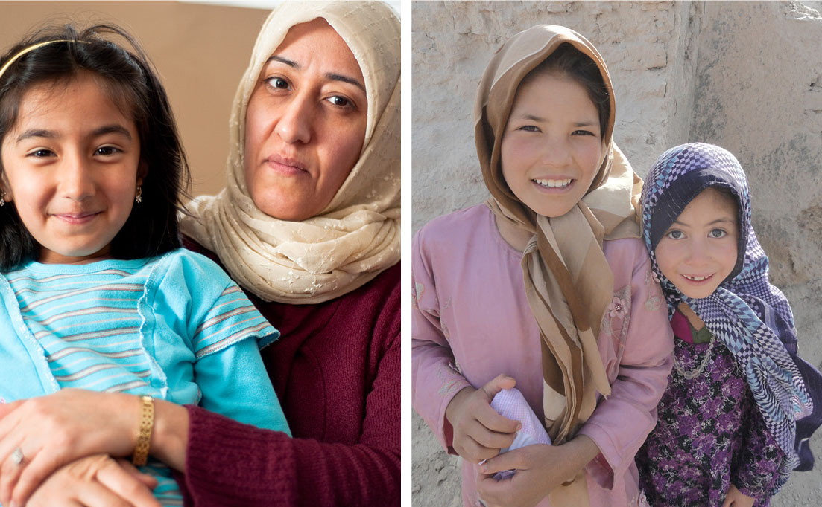
Photo Credit: UN Women / Michal Swan Photo Credit: Georgia National Guard

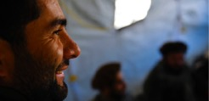
Client Story:
Mohammad*
Mohammad*, an Afghan man who worked with the U.S. government promoting women’s and children’s rights across Afghanistan, applied to the Special Immigrant Visa (SIV) program in 2019. Under continued threat from the Taliban, Mohammad managed to reach the United States, where he waited for the government to process his SIV application so that his wife and two sons could join him.
With his family still in danger in Afghanistan, Mohammad — consumed with fear and worry — was not able to truly begin his new life. In 2020, in a devastating turn of events, Mohammad’s wife died suddenly from a heart attack while being threatened directly by the Taliban, and his sons were forced into hiding with their grandmother and uncle, since they still had no path to safety in the United States.
When Afghanistan fell to the Taliban, the threats against Mohammad’s family escalated, yet Mohammad’s SIV application was still pending. In October 2021, IRAP sued the U.S. State Department on Mohammad’s behalf, seeking to ensure that the government fulfill its obligations to protect his family. “My greatest wish is to hug my kids again,” Mohammad said at the time. After months of advocacy, Mohammad finally received special immigrant status. His sons finally received their visas in January 2022 and were able to reunite with their father in the United States.
However, tens of thousands of SIV applicants and their families are still waiting for decisions in their cases. Others applied for humanitarian parole, like Mohammad’s mother and brother, who were unable to accompany the children they had cared for for so many months. Their applications, like thousands of others, were denied.
*Name and photo changed to protect client identity.
Safeguarding Existing Pathways to Safety
IRAP’s direct legal aid teams help forced migrants everywhere navigate pathways to safety, and our policy and litigation teams fight to keep these pathways accessible and responsive to the needs of people experiencing displacement.
Reuniting Unaccompanied Children with Relatives Around the World
Family reunification is part of many countries’ immigration systems, yet it remains unjustly inaccessible to many displaced people. IRAP collaborates with the United Nations High Commissioner for Refugees (UNHCR) through our Central Mediterranean regional partnership and with other UNHCR offices globally, governments in destination countries, and non-governmental organizations (NGOs) to help clients navigate this valuable pathway.
IRAP’s Europe-based team provides direct representation to help hundreds of separated family members — mainly unaccompanied children — obtain safe, legal passage and reunite with relatives. We use insights from our client work to identify barriers that can be remedied through systemic change efforts. For example, this year, we leveraged our casework to develop technical research and recommendations related to prohibitive documentation requirements for family reunification that have been formally recognized by German and Swedish migration authorities. IRAP also partners with Equal Rights Beyond Borders to provide legal assistance to refugees in Greece, including those seeking family reunification.
Notably, IRAP and UNHCR are working to finalize an unprecedented Memorandum of Understanding that will enable all UNHCR offices globally to refer cases eligible for family reunification to IRAP for legal representation.
In the United States, IRAP has redoubled our efforts to defend the Central American Minors (CAM) Refugee and Parole Program. When multiple states filed a lawsuit this year seeking to end CAM, IRAP — in collaboration with clients impacted by CAM —joined ongoing litigation to preserve this vital family reunification program. We also launched an NGO policy coalition to advocate for the Biden administration to protect CAM for its thousands of existing applicants, and expand eligibility to thousands of additional families. Through our litigation, advocacy, and strategic communications, IRAP is a leader in working to protect CAM as a pathway for family reunification.
Client Story:
Aaron* and Miriam*

Aaron* and Miriam* were separated from their mother when she was forced to flee their home in Eritrea. While their mother was able to safely resettle in Germany, the children stayed behind for safety reasons. After their mother reached Germany, the children moved to a refugee camp in Sudan since it is impossible to initiate family reunification proceedings from Eritrea. Thanks to IRAP’s collaboration with UNHCR, staff inside the camp had been trained by IRAP to identify cases eligible for family reunification, and Aaron and Miriam became IRAP clients. The German government initially denied the children’s application to reunite with their mother since they could not get passports because the Eritrean government considered the family traitors for fleeing the country. IRAP challenged the denial in German court, and won. Not only were Aaron and Miriam reunited with their mother in Germany in June 2021, but IRAP also began to establish a legal precedent to ease the German passport requirement for thousands of refugee children in similar situations.
*Names changed to protect client identity.

Safeguarding Existing Pathways to Safety
REBUILDING U.S. RESETTLEMENT SYSTEMS
IRAP advocates to ensure that the United States continues to provide safe haven for forced migrants through humane, welcoming policies.
In September 2022, IRAP and our coalition partners at the Refugee Advocacy Lab published a bipartisan letter signed by more than 380 state and local elected officials from all 50 states, the District of Columbia, and Puerto Rico, urging President Biden to invest in and rebuild the refugee resettlement program for the United States’ fiscal year 2023. As of August 31, with only a month left in its fiscal year 2022, the United States had admitted less than 16% of the maximum number of refugees it aimed to resettle. The U.S. government will continue to fall short of its refugee resettlement goal without substantially increased investment in and reform of the U.S. Refugee Admissions Program (USRAP). While we are glad that the United States was able to utilize creative new models of parole and private sponsorship to bring a combined total of over 150,000 Afghans and Ukrainians to safety this year, we continue to advocate for increased admissions for displaced people of all nationalities.
IRAP’s efforts, including strategic communications and media advocacy, also contributed to the State Department’s reinstatement of the Iraqi Priority-2 Direct Access Program (for Iraqi allies of the United States), which had been suspended in 2021. IRAP is leveraging momentum from this victory to push the government to address the application backlog that has left tens of thousands of U.S.-affiliated Iraqis and their families in danger.
Following extensive advocacy by IRAP, the Biden administration took important next steps toward creating an expanded channel for NGOs to augment the UNHCR referral system and refer cases directly to the U.S. resettlement program. This change will help bring the U.S. government closer to its refugee admissions goal and provide more equitable access to U.S. resettlement, especially for populations of particular concern.

Client Story:
Sam
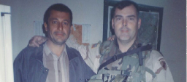
Sam, an Iraqi school teacher and interpreter for a U.S. Army Reserve unit, has shared his story many times over the course of his long journey to safety, bringing attention to the systemic issues faced by Iraqi and other refugees under the Trump administration. He was an IRAP client both during his application for resettlement through the Iraqi Direct Access Program (DAP) and as one of several plaintiffs in IRAP’s lawsuit against the Muslim refugee ban, which was co-counseled by the National Immigration Law Center (NILC), Perkins Coie, HIAS, and Lauren Aguiar, Mollie M. Kornreich, and Abigail Sheehan Davis.
Since Sam first applied for a visa to the United States in 2014, his case was affected by delays and setbacks, including due to the Muslim refugee ban and the COVID-19 pandemic. Despite support on his case from U.S. soldiers who had benefited from his work as a translator under dangerous circumstances in Iraq, Sam was stuck in Egypt, where he lived in hiding to protect his family, who were still in Iraq.
Applicants like Sam faced yet another dangerous delay after the U.S. government suddenly suspended the Iraqi DAP program in 2021, an action that affected hundreds of thousands of U.S.-affiliated Iraqis and their families at risk of retaliatory violence. IRAP used all available legal, policy, and litigation tools to advocate for Sam and others in similar situations, calling on the government to uphold its promises to them. Finally, on March 1, the State Department announced that the suspension would be lifted, allowing application processing for thousands of at-risk Iraqis to begin again. Later that month, Sam finally arrived in the United States, where he was welcomed with a warm embrace by one of the soldiers he worked alongside for so many years.
Ensuring Equity of Access to Safety
IRAP seeks to ensure that all displaced people are able to claim their legal rights equitably and with dignity.
Leading Efforts for Equal Protection in Jordan
In Jordan, two legal systems exist for forced migrants: one for Syrians and one for people of other nationalities. This double standard leaves tens of thousands of people who have fled to Jordan from countries like Somalia, Sri Lanka, Sudan, and Yemen unable to access humanitarian resources and without equitable protection from threats including human trafficking, detention, and deportation. As Co-Chair of the One Refugee Approach Working Group, IRAP advocates for a legal framework inclusive of all refugee groups in Jordan. IRAP’s Jordan staff is also working in partnership with embassies in Amman to form a diplomatic working group to address the unmet social, protection, and healthcare needs of displaced LGBTQIA+ populations facing worsening discrimination.
We are excited to have pivoted to an affirmative agenda to rebuild and expand pathways to safety in the United States, while continuing to advocate for government accountability and just, equitable policies toward displaced people at the federal, state, and local levels.
Client Story:
Hani*

In the 1980s, Hani’s* parents fled political persecution in Syria to build a new life in Jordan, where Hani was born. Hani, however, experienced persecution of his own in Jordan, including by his own family, for being gay. His brother threatened to kill him if he ever found out he was gay. In order to survive, he hid his identity, but he was still harassed and bullied because he was perceived as “not masculine enough.”
In 2020, a local NGO supporting LGBTQIA+ people referred Hani’s case to IRAP’s Jordan office. IRAP submitted a resettlement referral to UNHCR on Hani’s behalf, and UNHCR referred Hani to Norway for resettlement. His application was approved, and he traveled to Norway in January 2022. He is now living a safer and more secure life in Norway, where he can express himself freely without fear.
*Name and photo changed to protect client identity.

Equal Rights for All Who Seek Asylum in the United States
At the U.S.-Mexico border, accessible legal information and counsel are scarce for all forced migrants, but especially for those who have disabilities, are not Spanish speakers, or face discrimination because of their race or other aspects of their identities. Through our direct services and advocacy, IRAP is fighting to restore asylum access, which has been severely restricted by harmful policies like Title 42 and “Remain in Mexico” that force people seeking safety to wait indefinitely in precarious conditions in Mexico.
IRAP works with the Mexican NGO, Derechos Humanos Integrales en Acción (DHIA), and other local partners to disseminate Know Your Rights information, identify and screen potential clients, and provide legal aid to advance their claims. We also collaborate with Johns Hopkins University and local organizations to make medical documentation and legal assistance more accessible for migrants with disabilities.
To address the targeted anti-Black racism, isolation, and disparity in access to services that Haitian migrants experience in Mexico, IRAP has increased our legal services for the Haitian community at the U.S.-Mexico border. In 2022, we held three legal clinics with Haitian Creole interpretation and translation services — including two with our pro bono partner Manatt, Phelps & Phillips, LLP — to share legal information, help participants understand their rights and options, and provide additional legal representation for qualifying clients. These clinics have resulted in increased requests for assistance from Haitian migrants, demonstrating that there is a need among Haitian migrants at the U.S.-Mexico border for focused, linguistically-tailored legal services.
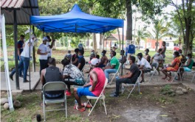
© European Union, 2021 (photographer: C.Palma)

Ensuring Equity of Access to Safety
Fighting the Continued Impact of the Trump Administration’s Muslim and African Bans
Despite President Biden’s rescission of the Muslim and African bans, the bans’ legacy continues to keep many Muslim and African refugee families apart. This year, IRAP engaged in extensive advocacy, including publishing an open letter signed by more than 75 partner organizations and calling on the Biden administration to dismantle all vestiges of the bans and end egregious processing delays that prevent refugee families from reuniting. We also filed litigation challenging unreasonable delays and discriminatory denials of applications connected to the Muslim ban, including two lawsuits on behalf of Somali refugee families who had been approved to reunite in the United States before the ban was enacted, but who remained separated after it was lifted. One of the families was reunited in July 2022, and we will continue fighting so that the second family, and others like them, can also be reunited in safety.
Broadening the Definition of Marriage in the U.S. Resettlement Program
After extensive advocacy by IRAP, U.S. Citizenship and Immigration Services (USCIS) implemented an important policy change this year to recognize certain refugee marriages, including interfaith and LGBTQIA+ unions, that are not legally recognized in countries of origin or asylum. This change, and the legal resources that IRAP published for affected refugees, asylees, and their advocates, help ensure equity of access to U.S. migration pathways.
We are proud to advance principles of equality and fairness so that all displaced people have equitable access to pathways to safety regardless of religion, race, nationality, language, sexual orientation, gender identity, or disability.

Client Story:
Afkab *
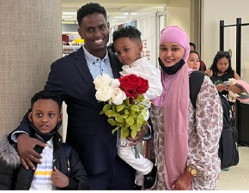
Afkab and his wife are Somali refugees who met and married while living in a Kenyan refugee camp. When Afkab received approval to resettle in the United States, it was too late to add his new wife to his case without causing significant delays. He made the difficult decision to travel to the United States alone and file for family reunification as soon as he arrived.
But when former President Trump’s Muslim refugee ban, which suspended family reunification under the follow-to-join program, threatened the chance that his wife and their newborn would be able to reunite with Afkab in the United States, he became a plaintiff in IRAP’s lawsuit, JFS v. Trump. With Afkab’s partnership, IRAP successfully obtained a preliminary injunction against the ban and negotiated a settlement agreement in February 2020, which required the government to prioritize processing of Afkab’s family’s case, as well as others who would have traveled to the United States but for Trump’s ban. Despite the government’s commitment to prioritize processing for Afkab’s case, the family remained separated several years later. At that point, Afkab had seen his young son only once in person.
As conditions worsened in Nairobi, where Afkab’s family continued to wait for a decision on their case, Afkab again agreed to partner with IRAP in March 2022 by filing another lawsuit – this time challenging the government’s unreasonable delay in processing the family’s follow-to-join petition.
In early July 2022, more than six years after Afkab began the application process for his family to join him in the United States so they could live together in safety, they were finally reunited. “I’m feeling so excited,” Afkab said when meeting them at the airport.

Innovating New Pathways to Safety
IRAP teams are working to open new pathways to safety and develop new legal frameworks that will provide lasting refuge for more displaced people.
Developing a Legal Framework to Protect People Displaced by Climate Change
Climate-related displacement has already eclipsed conflict as the leading cause of internal forced migration, but no domestic laws or multilateral treaties to protect climate-affected populations exist. IRAP is working with partners to accelerate the development of legal protections in the Americas for people displaced by environmental devastation, which could serve as prototypes for other regions. We are also collaborating with partners to develop training materials for asylum and refugee officers to better evaluate situations when climate contributes to displacement and international protection is warranted. Furthermore, in December 2021, IRAP and 12 partner organizations sent a letter to the White House demanding concrete action to address climate displacement and in May 2022, we successfully advocated for members of the U.S. House of Representatives to support a letter calling for Temporary Protected Status for people from climate-vulnerable Central American countries. Looking ahead, IRAP is planning our second convening with partners in the climate and immigration justice movements to advance these efforts and develop a community of practice working toward legal protections for climate-displaced people.
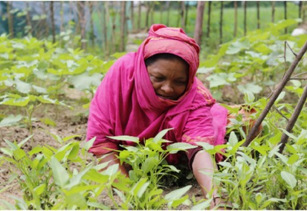
Photo Credit: UN Women / Mahmudul Karim
Launching Private Sponsorship of Refugees in the United States
IRAP is a leading advocate for private sponsorship of refugees in the United States, which will expand resettlement opportunities and resources by allowing civil society organizations and private groups of individuals to directly support newcomers. This year, we played a key advisory role in the development of community sponsorship programs for Afghans and Ukrainians. We also published joint recommendations with Amnesty International USA, the Community Sponsorship Hub, and the Niskanen Center for a U.S. private sponsorship pilot program for refugees of all nationalities. Our advocacy contributed to the Biden administration’s announcement that it intends to launch such a program later this year.
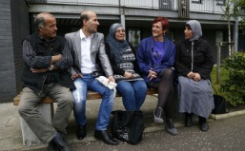
Photo Credit: Scottish Government

Photo Credit: Scottish Government
Securing Lasting Refuge in the United States
IRAP staff advocate to ensure that once displaced people reach immediate safety in the United States, they also have the opportunity to seek permanent refuge.
Reaching safety is only the first step on a displaced person’s journey to rebuilding their life.
In the case of Afghans evacuated to the United States, most entered the country on humanitarian parole, a temporary status that does not provide a pathway to permanent residency or benefits. To address the latter, we successfully advocated for the September 2021 passage of a bill that provided $6.3 billion for resettlement and benefits to help Afghans paroled into the United States. We have also played a leading role in building bipartisan support for the Afghan Adjustment Act, a bill introduced in Congress in August 2022 that would provide a pathway to Green Cards for Afghan parolees.
Parallel to these efforts, IRAP lawyers, with volunteers from law firms and student chapter partners, organized clinics for Afghans in Sacramento, California and Rochester, New York that provided legal aid and information to help them pursue lasting refuge. We continue to expand the reach of our legal expertise through our legal information website, partnership with the International Rescue Committee to support the legal aspects of their work with Afghans, Ask An Expert online portal, and online training sessions that have served thousands of legal practitioners and resettlement agency staff.
Furthermore, as a co-founder of the Refugee Advocacy Lab, IRAP advocates and provides technical legal support to advance state and local policies benefiting refugees of all nationalities. By providing easier access to necessities like school enrollment, occupational licensing, and COVID-19 relief funding, these policies facilitate a smoother transition to life in the United States. We also work with our student chapters to assist former clients of any nationality in the United States with U.S. citizenship applications. Collectively, these efforts help people rebuild their lives with permanence and dignity.

Client Story:
Julissa
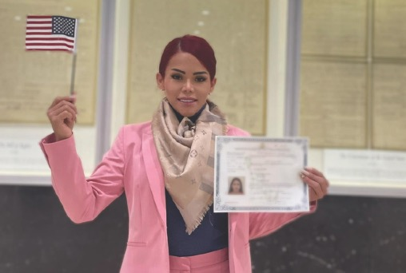
Julissa was granted asylum in the United States after she fled El Salvador seeking safety from anti-LGBTQIA+ discrimination, but her future in her new home country was still uncertain. IRAP worked with Julissa to apply for permanent residency—her Green Card—but excessive administrative delays meant that IRAP had to engage in extensive advocacy to cut through the red tape.
Even after Julissa received her Green Card, her path to citizenship was not a simple one. Julissa had been subjected to discriminatory police interactions during her time in the United States, and U.S. Citizenship and Immigration Services was trying to use information about these encounters to withhold citizenship from her. Ultimately, Julissa and IRAP were successful in getting her application approved, and Julissa was sworn in as a U.S. citizen in early 2022.

Student Chapters

IRAP helps develop the next generation of legal advocates for displaced people through our partnerships with law school student chapters.
Student chapter members provided critical assistance to IRAP’s legal, litigation, and policy teams over the past year, including preparing legal research, advocating for IRAP’s policy priorities on Capitol Hill, working on client cases with IRAP attorneys and pro bono partner attorneys, and conducting outreach to displaced populations to help them identify pathways to safety for which they may be eligible.
“Volunteering with IRAP has made me a better advocate and improved my ability to creatively solve problems. Through my work on [an IRAP] case, I have learned about the patience and dedication required to assist individuals through the opaque, lengthy, and stressful immigration process. Working with IRAP has had a profound impact on how I think about lawyering. IRAP is a global law firm that not only serves clients, but it has a larger mission of ensuring that people displaced by war, persecution, regime change, and climate change get support that they need and the causes of their displacement are discussed and their voices are amplified. I am really grateful to be a volunteer with an organization with an incredible impact and legacy.”
— Hailey Phelan, University of California at Irvine, recipient of IRAP’s 2022 Excellent Case Team award

“For the past year and a half, I’ve had the opportunity to work with amazing attorneys from IRAP and with three phenomenal Steptoe & Johnson LLP attorneys who have all taught me so much about creative thinking in a difficult and complex case and about the importance of paying attention to even the tiniest details. I think we all agree that the recognition is really [for] our client for his fortitude and his grace throughout this difficult and drawn out process. [He] is an incredible self advocate and we want to thank him for his thoughtfulness, his diligence, and his willingness to trust all of us with this case.”
— Kiri Van Lengen-Welty, NYU School of Law, recipient of IRAP’s 2022 Excellent Case Team award

Law School Chapters

American University Washington
College of Law
Boston University School of Law
City University of New York School of Law
Columbia Law School
Cornell Law School
Emory University School of Law
Fordham University School of Law
George Washington University Law
School
Georgetown University Law Center
Harvard Law School
McGill University Faculty of Law
New York University School of Law
Northwestern University Pritzker School of Law
Osgoode Hall School of Law
Rutgers School of Law
Seattle University School of Law
Stanford Law School
Touro Law Center
University of Alabama School of Law
University of California, Berkeley School of Law
University of California, Irvine School of Law
University of California, Los Angeles School of Law
University of Chicago Law School
University of Connecticut School of Law
University of Michigan Law School
University of Pennsylvania Law School
University of Southern California, Gould School of Law
University of Virginia School of Law
Yale Law School

Pro Bono Partners
IRAP’s pro bono network plays an invaluable role in providing clients with expert legal assistance and bolstering IRAP’s litigation and advocacy efforts to defend the rights of forced migrants.
We are grateful and proud that in 2021, IRAP’s pro bono partners provided over 32,400 hours of free legal aid, valued at over $21 million, to help displaced people seeking safety.

“AIG is very proud to be recognized for its work with IRAP. In August 2021, as we watched Kabul fall to the Taliban, a team of lawyers, interpreters, and business analysts from AIG worked around the clock with IRAP to assess options for evacuation and analyze immigration issues for our clients. It is more important than ever to continue this work and ensure that Afghan refugees here and abroad receive top notch legal advice. These experiences serve as important reminders of how fortunate we are and our responsibility to continue this vital work. We are very proud of these efforts and look forward to continuing our work with IRAP to help our refugee clients.”
— Erica Blau, AIG, recipient of IRAP’s 2022 Excellent Pro Bono Partner award
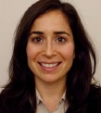

AIG
Akin Gump Strauss Hauer & Feld LLP
Allen & Overy
Alston & Bird LLP
Arnold & Porter Kaye Scholer LLP
Ashurst
Barasch McGarry Salzman & Penson
Bradley Arant Boult Cummings LLP
Brown Rudnick LLP
Bush Seyferth PLLC
Cleary Gottlieb Steen & Hamilton LLP
Clifford Chance US LLP
Covington & Burling LLP
Davis Polk & Wardwell LLP
Deloitte
Dentons US LLP
DLA Piper LLP (US)
Duane Morris LLP
Dykema Gossett PLLC
Faegre Drinker Biddle & Reath LLP
Fenwick & West LLP
Fragomen, Del Rey, Bernsen & Loewy, LLP
Freshfields Bruckhaus Deringer
Gibson, Dunn & Crutcher LLP
Goulston & Storrs P.C.
Greenberg Traurig, LLP
GxG Legal
Haynes and Boone, LLP
Hogan Lovells US LLP
Holwell Shuster & Goldberg LLP
Hunton Andrews Kurth LLP
Jenner & Block
K&L Gates LLP
Kilpatrick Townsend & Stockton LLP
King & Spalding LLP
Kirkland & Ellis LLP
Latham & Watkins LLP
Law Offices of Carl G. Roberts
Linklaters LLP
Littler Mendelson P.C.
Lowenstein Sandler LLP
Manatt, Phelps & Phillips, LLP
Microsoft
Moore & Van Allen PLLC
Morgan Lewis & Bockius LLP
Neal, Gerber & Eisenberg LLP
Nixon Peabody LLP
Orrick, Herrington & Sutcliffe LLP
Parker, Hudson, Rainer & Dobbs LLP
Patterson Belknap Webb & Tyler LLP
Paul, Weiss, Rifkind, Wharton & Garrison LLP
Perkins Coie LLP
Poles, Tublin, Stratakis & Gonzalez, LLP
Proskauer Rose LLP
Reed Smith LLP
Ropes & Gray LLP
Rosenstock Legal Services
Schiff Hardin LLP
Shearman & Sterling LLP
Sheppard, Mullin, Richter & Hampton LLP
Sidley Austin LLP
Simpson Thacher & Bartlett LLP
Skadden, Arps, Slate, Meagher & Flom LLP
Steptoe & Johnson LLP
Sullivan & Cromwell LLP
Synchrony Financial
Three Crowns
Venable LLP
Weil, Gotshal & Manges LLP
White & Case LLP
Whiteman Osterman & Hanna LLP
Wilson Sonsini Goodrich & Rosati
Winston & Strawn LLP
Youman, Madeo & Fasano, LLP

Our Supporters
IRAP extends our profound gratitude to our generous supporters who made gifts to us this past fiscal year — September 1, 2021 to August 31, 2022.

The Audacious Project
IRAP’s funding through The Audacious Project is made possible thanks to the partnership of inspiring and forward-thinking donors and social entrepreneurs, including:
Anonymous (6)
Charles and Lynn Schusterman Family Philanthropies
Galaxy Gives
Joe Gebbia and Isabelle Boemeke
Laura and Gary Lauder and Family
Lyna Lam and Chris Larsen
MacKenzie Scott
Pivotal Ventures
Rippleworks
Silicon Valley Community Foundation
The Patchwork Collective
Valhalla Foundation
$100,000+
Anonymous (2)
Democracy Fund
DKT Liberty Project
Ford Foundation
Frederick Iseman
FWD.us Education Fund
G. Barrie Landry, Landry Family Foundation
Mary Ann Stein
Microsoft
MSL Fund
Open Philanthropy
Open Society Foundations
Patti and Everett B. Birch Foundation
Price Philanthropies Foundation
Robert J. Abernethy
Rockefeller Brothers Fund
The Anne Wojcicki Foundation
The Morningstar Foundation
The Norris Family Charitable Fund
The Shapiro Foundation
The Sigrid Rausing Trust
The Tepper Foundation
Twitter
United Nations High Commissioner for Refugees
United Nations Voluntary Fund for Victims of Torture
$50,000-$99,999
AIG
Anna and Carl Reisner
Anonymous (2)
Bain Capital
Carnegie Corporation of New York
Double Up Drive
FJC - A Foundation of Philanthropic Funds
Jacob and Hilda Blaustein Foundation
Kaplan Hecker & Fink LLP
Morton K. and Jane Blaustein Foundation
Rachel and Mike Jacobellis
Ruthie Byers
The Blackstone Charitable Foundation
The Grove Foundation
Unbound Philanthropy
Wild Elements Foundation (a sponsored program of the Social Impact Fund)
Wild Thyme Fund
Zegar Family Foundation

$25,000-$49,999
Anonymous (3)
Clifford Family Foundation
Jill Kirshner
Katie McGrath & J.J. Abrams Family Foundation
Khudairi Group
Catherine and Subhi Khudairi
Kirkland & Ellis LLP
Maddula Family Foundation
Paul, Weiss, Rifkind, Wharton & Garrison LLP
Rich Olcott
Ropes & Gray LLP
Samuel I. Newhouse Foundation
Shearman & Sterling LLP
Skadden, Arps, Slate, Meagher & Flom LLP
Tali and Boaz Weinstein Philanthropic Fund
The 3C Foundation
Weil, Gotshal & Manges LLP
$10,000-$24,999
AJG Fund
Alchemy Foundation
Anna Fuller Charitable Fund
Anonymous (7)
Apple, Inc.
Big Cartel
Choose Love, Inc.
Chris Dunn
Chungche Chang and Horng-Wen Hsieh
Cohn Charitable Fund
DLA Piper LLP (US)
Dr. Bronner’s Family Foundation
Freshfields Bruckhaus Deringer
Gibson, Dunn & Crutcher LLP
Gloria Principe and John O’Farrell
Google Inc. (via American Endowment Foundation)
Herb Block Foundation
JS Howe Family Foundation
King & Spalding LLP
Latham & Watkins LLP
Linklaters LLP
Lisa F. Arpaia, Esq. and David Anthony
Orrick, Herrington & Sutcliffe LLP
Paulette Meyer and David Friedman
Robert & Jane Toll Foundation
Rutgers Presbyterian Church
Skoll Foundation
Solomon Family Foundation
Stempel Family Charitable Fund
Steve and Julie Hearst
Susan Benson and William Martin
The Altschul Foundation
The Morrison & Foerster Foundation
The Steptoe Foundation
United Continental Holdings, Inc.
Walt and Joy Cooper
Wellington Shields & Co, LLC
Wormser Giving Fund

$5,000-$9,999
Anonymous (10)
Argosy Foundation
Arnold & Porter Kaye Scholer LLP
Ashurst
Barinaga Goodman Fund of West Marin Fund
Bruce Waters
Carol and Gene Ludwig Family Foundation
Clifford Chance US LLP
Colleen A. Montag Donor Advised Fund
Colleen Feigenwinter
Cowan, Liebowitz & Latman, P.C.
Dan Gould/Marina Kim Fund
Deepak Eachempati Giving Fund
Dentons US LLP
Edwin-Steirn Charitable Fund
Elizabeth Haddad
Faegre Drinker Biddle & Reath LLP
Fenwick & West LLP
Gail and Gerrish Milliken
Higgins Trapnell Family Foundation
Hogan Lovells US LLP
Intel Corporation
Isaac Cohen
Jane Ladner
Julie Ehrlich and Noam Elcott Fund
Lucas Sanders
Miriam Buhl
Nathoo Family Donor Advised Fund
Netflix
New Year Fund
NFC Momentum Fund
Nixon Peabody LLP
Participant
Peter & Elizabeth Tower Foundation
Phyllis Hatfield
Rich and Gina Kelley
Richard Yannow
Robert Friedman
Rosemary Christoff Dolan, in memory of her immigrant parents, Steven and Marie Christoff
Seligman Onward & Upward Fund
Shankar LeVine
Sheppard, Mullin, Richter & Hampton LLP
Simpson Thacher & Bartlett LLP
Taryn Higashi and Ivan Zimmerman
The Adams Green Family Fund
The Cruz Family Foundation
The Michie Family Fund
The Open Door
The Wilson Sonsini Goodrich & Rosati Foundation
Tiia Carswell
Umrai Gill
White & Case LLP
Zoltan Turi and Adele Slatko

Board of Directors and Advisory Board
We are deeply grateful to the individuals who contribute their time and expertise as members of IRAP’s Board of Directors and Advisory Board.
Board of Directors
Robert J. Abernethy, President, American Standard Development Company and Self Storage Management Company; Managing Director, Metropolitan Investments, LLC
Nadia Allaudin, Managing Director, Wealth Management Advisor, CIMA, Merrill Lynch Wealth Management
Ahilan Arulanantham, Professor from Practice and Faculty Co-Director of the Center for Immigration Law and Policy, UCLA School of Law
Miriam Buhl, Pro Bono Counsel, Weil, Gotshal & Manges, LLP
Joe Cerrell, Managing Director, Global Policy and Advocacy, and Interim Director, Development Policy and Finance, Bill & Melinda Gates Foundation
Mazen Darwish, Founder and Director, Syrian Center for Media and Freedom of Expression
Taryn Higashi (Board Chair), Executive Director, Unbound Philanthropy
Mike Jacobellis, Chief Investment Officer, New Holland Capital
Subhi Khudairi, Founding Managing Partner and President, Khudairi Group
Michael Madnick, CEO, Mountain Philanthropies
Carl Reisner, Co-Head of Mergers and Acquisitions, Paul, Weiss, Rifkind, Wharton &
Garrison LLP
Zainab Salbi, Founder of Women for Women International, Media Host, and Best-Selling Author
Edward Shapiro, Managing Trustee, The Shapiro Foundation; President, Shapiro Investment Company, LLC

Advisory Board
Michael Breen, President and CEO, Human Rights First
Walt Cooper, Head of Innovation, Walmart Health
Stephanie Cornell, Managing Director, Draper Richards Kaplan Foundation
Patricia A. Gruber, Peter and Patricia Gruber Foundation
Zach Iscol, Executive Director, Headstrong Project; Founder and CEO, Hirepurpose
Amed Khan, Founder, Elpida Home; Founder & President, Zaka Khan Foundation
Steven M. Miska, Founder, SLC Consulting, Inc.; Colonel (Retired), U.S. Army
Alex O’Neill, Associate, Harvard Kennedy School; Graduate Student, University of Oxford
John Oliver, Comedian and Host of HBO’s Last Week Tonight with John Oliver
Robert Raben, President and Founder, The Raben Group
Abbas Ravjani, Privacy and Public Policy Manager, Facebook
Neal Rickner, Managing Partner, Elevation Ventures
Thomas A. Russo, Executive Vice President and General Counsel, Legal, Compliance, Regulatory Affairs & Government Affairs, (Retired), American International Group, Inc.

IRAP, Inc. Fiscal Year 2022 Financials
We truly appreciate the dedicated community that makes our work possible.
Together, we will continue working to ensure that displaced people are able to know and access their rights as they seek safe, lasting refuge.

Expenses
$16,881,473
81.2%
Programs
Legal Services 53%
Litigation 15.9%
Policy 8.8%
Communications 5.6%
Other (CLIMATE DISPLACEMENT,
LEGAL STRATEGY, MONITORING &
EVALUATION, AND PRO BONO) 3.6%

7.5%
FUNDRAISING

11.3%
on MANAGEMENT

REVENUE
$17,851,971
37.7%
Foundation Contribution Income
47.9%
Individual Contribution Income
9.2%
Corporate Contribution Income

4.4%
CONTRIBUTION INCOME THROUGH THE AUDACIOUS PROJECT
4.8%
INTEREST & OTHER REVENUE

Expenses include fiscal year 2022 components of a six-year growth project funded through The Audacious Project to which we have committed. Revenue includes only the portion of total growth project funding allocated to the project’s initial year.
The International Refugee Assistance Project is an independent 501(c)(3) nonprofit organization committed to transparency and accountability. At the time of this report’s publication, IRAP is undergoing our annual audit, to be completed in late 2022. As such, these graphs reflect unaudited financial numbers. Our most recent financials are available on the IRAP website. Upon completion of our annual audit, IRAP will publish the independently-audited financial statements for the fiscal year which ended August 31, 2022, along with IRAP’s 990 filings, on our website.

